Fulcrum Publishing Society
Board of Directors
MINUTES

Sunday, March 3rd, 2019
141 Louis Pasteur, 11:00 a.m. - 2:31 p.m.
Meeting #9 2018-2019 Publishing Year

Present: Kate Murray, Jonathan Rausseo, Dorian Ghosn (ex-officio), Justin Turcotte, Anchal Sharma (ex-officio), Graham Robertson, Dayne Moyer, Rachel Hammond
Partially Present:
Absent (with reason): Raghad Sheikh-Khalil, Justin Turcotte, Donya Ashnaei, Kaylum Bobal (ex-officio)
Absent (without reason):

- Opening of Meeting

G. Robertson called the meeting to order at 11:15am.

- Agenda

D. Moyer motioned to approve the agenda. J. Rausseo seconded the motion. All voted in favour and the motion passed.

- February Meeting Minutes

J. Rausseo motioned to approve February’s meeting minutes. K. Murray seconded the motion. All voted in favour and the motion passed.

- Standing Actions List

G. Robertson went over the standing actions list and J. Rausseo and K. Murray made the necessary changes.

- General Manager

D. Ghosn began his report by reviewing The Fulcrum’s current financials. He indicated that The Fulcrum only has approximately $29,000 left in its chequing account, but noted that the RBC account is up a bit. D. Ghosn stressed that The Fulcrum needs to stay precautionary with spending.

D. Ghosn mentioned that the marketing committee had their third meeting with the marketing consultant on Thursday, stating that G. Robertson will talk more about it in his report.

D. Ghosn informed the Board that Bell has imposed a nationwide price increase on all of their accounts that started in January. He explained that he called Bell to express his concerns, and The Fulcrum was given a one-time $45 credit on its next bill. D. Ghosn stated that The Fulcrum will probably have to look into cancelling the phone lines and proceeded to review what cancelling the contract would involve. Discussion ensued over this possibility. J. Rausseo motioned to cancel the phone line and negotiate a cancelation fee. D. Moyer seconded the motion. All voted in favour and the motion passed.

D. Ghosn stated that The Fulcrum has officially received its HST refund, and has been deposited into The Fulcrum’s account.

D. Ghosn reported that the driver for TC delivered the February issue to the UCU again by mistake, and that the administration had to remove everything off the skid and may have disposed of some copies of the paper. He continued by stating that he was able to speak with their administrator and was able to get in courier in to get the papers out. D. Ghosn mentioned that he explained the issue and expressed our concerns to The Fulcrum’s contact at TC and they will be providing The Fulcrum with a discount on the final two print issues. He added that they were very understanding and that they have spoken with the driver to ensure that it doesn’t happen again.

K. Murray motioned to add fifteen minutes to the discussion. J. Rausseo seconded the motion. All voted in favour and the motion passed.

Discussion ensued on the remaining print issues. J. Rausseo stated that we should find out from K. Bobal what The Fulcrum’s advertising commitments are for the final issue. He mentioned that if it’s less than $500-1000, he thinks that we should get rid of it.

D. Ghosn announced that The Fulcrum’s Arts and Cultures Editor and Associate News positions have been filled, and noted that A. Sharma will speak about this in more detail in her report.

D. Ghosn updated the Board that The Fulcrum has received our winter GSAED disbursement, which has been deposited into The Fulcrum’s account.

D. Ghosn informed the Board that The Fulcrum have still yet to receive the fall and winter levies from the SFUO. He explained that he has contacted Faduma from the SFUO, and that she informed him that she would follow up with their accountants. D. Ghosn continued that he has since followed up with the SFUO, but has yet to hear anything back from them. He mentioned that he’s not sure why there has been such a delay in receiving the funds as The Fulcrum usually receives it in December. D. Ghosn added that when he, J. Rausseo, J. Turcotte, R. Sheikh-Khalil, and K. Murray met with Paige after our last Board meeting, they had guaranteed that The Fulcrum would be given it before reading week. Discussion ensued on how the Board should proceed.

D. Ghosn concluded his report by mentioning that he, J. Rausseo, and R. Sheikh-Khalil have met a few times to put together a rough draft of The Fulcrum’s budget for next year. He said that it’s been tough trying to figure out The Fulcrum’s financial situation given the uncertainty over whether we’ll be receiving the levies this year let alone next year.

- Marketing Manager

Since K. Bobal was not present, G. Robertson read K. Bobal’s report aloud to the Board.

K. Bobal’s report began by reviewing The Fulcrum’s current and monthly advertising sales and online sales. He noted that The Fulcrum is currently below its anticipated average going into April’s special issue. K. Bobal asked if D. Moyer has the time and is willing to, would they be able to work together for the final issue. K. Bobal indicated that there are still two ads that are being rotated on The Fulcrum’s website. He mentioned that St. Paul’s University has placed their first online big box ad which will rotating with Metro’s during the month of March. K. Bobal added that The Fulcrum will have one leaderboard that will continue throughout the summer.

In his report, K. Bobal informed the Board that a social media contest was planned for the week before the Oscar party, but he didn’t realize that it was reading week, so he had to change it to the following Monday. With that said, he stated that the contest wasn’t posted. He explained that he sent an email to Christine with the picture and caption to be posted, but he didn’t hear back from her. K. Bobal continued by stating that he tried to post it himself, but he had some issues in doing so.

K. Bobal mentioned that he ran a social media contest for Capital Hoops on Twitter and Facebook, and he reached out to the winner from the Twitter contest, but they didn’t respond.

K. Bobal announced that the Oscar night went really well. He explained that he was able to negotiate a higher budget for spending at the Royal Oak, which The Fulcrum ended up staying within.

K. Bobal stated that he’s working on arranging a pub trivia night at Fathers and Sons in March. He said that he’ll be meeting with Mike on Monday to discuss the details and will need to meet with A. Sharma as well to discuss trivia questions and the schedule for the night.

K. Bobal said that A. Sharma is waiting for a response from the guest speaker before setting anything up. He also updated the Board on Poutine Fest, noting that it is still planned and that The Fulcrum’s social media contest that week will fall within community life.

K. Bobal concluded his report by indicating that he uploaded his marketing report onto the drive. He explained that a lot of the goals and objectives that he set are concerned with growing The Fulcrum’s socials.

- Editor-in-Chief

A. Sharma announced that she and D. Ghosn conducted interviews for the Arts and Culture Editor and Associate News positions. She informed the Board that the interviews were successful, and that the new editors have been working this week, and will need to be ratified by the Board later on this meeting. A. Sharma mentioned that she and the Managing Editor have conducted some performance reviews this month and plan to do the rest this week.

A. Sharma stated that the Sex issue was published last month, and the next issue coming up is the Mental Health issue. She informed the Board that there were some delays with February’s print issue due to the weather, so it was a few days late. A. Sharma explained that The Fulcrum doesn’t usually publish the week before reading week, but the ed board had a few stories coming out that week since they skipped a week in January. She added that staff have compensated for it in January.

A. Sharma reminded that The Fulcrum owes freelancers money at the end of each month.

A. Sharma mentioned that she attended the last conference call meeting with the Ontario CUP representatives where they discussed hiring a lobbying firm. She wondered if The Fulcrum are going through with their lobbying efforts, and asked how editorial is involved. A. Sharma added that they are having another call tomorrow. J. Rausseo briefly went over the discussion that he, D. Ghosn, R. Sheikh-Khalil, and K. Murray had about this following their meeting with Paige from the SFUO.

A. Sharma reported that she started the process for the EIC elections, and said that she’s had a few people shadow her this past month. She announced that the EIC elections will take place on March 5th after the volunteer meeting. A. Sharma explained that Matt Gergyek is the only candidate. She noted that he passed the EIC test on Friday, and that she’s passed around his resume and platform to voting members. A. Sharma mentioned that they normally provide pizza during the election as it tends to last a long time. D. Ghosn stated that there isn’t much left in the budget for pizza, but that he will look into what he can get at Fathers and Sons as The Fulcrum has contra with them. A. Sharma also noted that she was having issues with forming the election committee, but she was able to figure it out.

A. Sharma revealed that she started a newsletter that goes out every Monday with updates on events and featured stories. She reported that The Fulcrum’s section editor workshops haven’t been getting a very high turnout. A. Sharma said that Christine has been promoting them online, and that she herself has been mentioning them in her weekly newsletter. With that said though, she stated that they editors will continue to hold the workshops and will post the presentations on The Fulcrum’s contributors Facebook group.

A. Sharma mentioned that The Fulcrum hosted an Oscar party at the Royal Oak on Laurier. She thanked K. Bobal for coordinating that with the Royal Oak and to J. Turcotte for making the ballots. A. Sharma went on to announce that The Fulcrum has a trivia night scheduled for March 9th, but she raised concerns that it hasn’t been promoted at all yet and thinks that there isn’t enough time to get everything out. She noted that she needs to meet with K. Bobal about it, but suggested moving it back about two weeks.

A. Sharma informed the Board that she followed up with Jane Lytvynenko from Buzzfeed, and she’s interested in doing a Skype workshop for The Fulcrum.

A. Sharma briefly reviewed the most recent social media report, which can be found on the Google Drive. D. Moyer motioned to add five more minutes to the discussion. J. Rausseo seconded the motion. All voted in favour and the motion passed.

A. Sharma indicated that she hasn’t had the chance to look at the results from the readership survey yet, but that she will do so as soon as things have calmed down for her. A. Sharma thanked R. Sheikh-Khalil for starting a dialogue with Omar from CHUO. She reported that she replied to him and Emmanuel this week, and they are trying to set something up with The Fulcrum’s new Arts and Cultures editor for Thursday.

A. Sharma concluded her report by outlining a couple of ongoing/new projects that she has, including: potentially having a panel with La Rotonde and conducting job shadowing in March for volunteers.

- President’s Report

G. Robertson read R. Sheikh-Khalil’s report aloud to the Board as she wasn’t present at the meeting.

Legal
-Student Union Referendum
R. Sheikh-Khalil informed the Board that herself, K. Murray, J. Rausseo, J. Turcotte, and D. Ghosn met with the SFUO before the referendum on January 29th. She explained that the SFUO executive discussed when The Fulcrum should be receiving its levies, and gave any details that they have regarding the government’s student choice initiative. R. Sheikh-Khalil noted that the minutes from this meeting can be found on the Google drive.

R. Sheikh-Khalil mentioned that the student union referendum was held from February 8-11th, and that the SFUO lost the election to the new student union, the UOSU. She reported that the new union must hold elections in the next few months to determine their executive team, and added that unfortunately The Fulcrum won’t be able to contact anyone until then.

R. Sheikh-Khalil stated that The Fulcrum was under the assumption that student fees would be passed over to the new student union, however a recent statement from the UOttawa administration stated the following: “It is up to the newly-elected student association to determine which services should be offered. For each service, it will be responsible for securing the agreement of undergraduate students. That process will have to take into account the framework for student fees announced by the Ontario government earlier this year.” With that said, R. Sheikh-Khalil noted that The Fulcrum is a little unclear on the state of its levy as of next year.

-Meeting with Fulcrum lawyer re: provincial government cuts
R. Sheikh-Khalil informed the Board that she and D. Ghosn met with The Fulcrum’s pro bono lawyer to discuss the current situation with the Ford government as well as the student referendum, briefly. She reported that the lawyer advised that legal action against the government would be almost unprecedented, and would not be advisable. R. Sheikh-Khalil continued, saying that the lawyer agreed that a lobby effort is in The Fulcrum’s best interests. She noted that in terms of potential legal action against the university, The Fulcrum’s lawyer would not be able to help The Fulcrum as her firm represents the university and that would constitute a conflict of interest.

-ORCUP lobby campaign
R. Sheikh-Khalil indicated that she had a meeting with the other Ontario papers to discuss the Lobby campaign. She also stated that she has spoken with representatives from La Rotonde and The Charlatan to have them join the meeting as well as they are not members of CUP. R. Sheikh-Khalil noted that the meeting discussed the contract with the new firm, Eamscliffe, the current strategy, and how much each paper can contribute. She mentioned that there are four documents in this month’s meeting folder on the drive regarding this meeting and its specific details.

R. Sheikh-Khalil informed the Board that the lobby firm will cost $23,000 over three months, and reminded everyone that The Fulcrum pledged to contribute $4500 over three months.

R. Sheikh-Khalil detailed that another important takeaway from the meeting was that given The Varsity’s reporting on the student choice initiative, it is not The Fulcrum’s best move to directly lobby the university. D. Moyer said that the Board should be talking with faculties and sports programs to get their support. J. Rausseo agreed and added that the Board should also approach the digital journalism program.

R. Sheikh-Khalil disclosed that she is still waiting to hear whether the group has received all the necessary funding to hire the firm, which she should know soon. She mentioned that if the Lobby effort doesn’t pull through, the BOD and the EdBoard will need to come up with an organized campaign to advocate for the paper.

Finance
-SFUO update
R. Sheikh-Khalil stated that she believes The Fulcrum received its fall levy, and that the winter levy should be arriving soon. She added that the SFUO executive mentioned that they will talk to the university about the levy coming so late.

R. Sheikh-Khalil reminded the Board that the finance committee needs to draft a ghost budget for next year without a levy as well as a regular budget with a levy as soon as possible.

-Budgeting note
R. Sheikh-Khalil stressed again that given the uncertainty of The Fulcrum’s financial situation this Winter, any non-discretionary spending is on hold if it hasn’t already been budgeted for. She added that if you are uncertain about what counts as non-discretionary, ask her or J. Rausseo.

HR
-Employee roundtables
R. Sheikh-Khalil stated that she did not meet with the full-time staff this month, but that monthly bilats will be scheduled at the February Board meeting.

-New employees
R. Sheikh-Khalil recorded that Ryan Pepper has been acting as the Arts and Cultures Editor through the emergency hiring procedure. She continued by noting that A. Sharma has begun to advertise for his replacement.

Training
-R. Sheikh-Khalil announced that the strategic planning committee will be meeting to discuss goals for the training session this semester, and that the theme will be the future of The Fulcrum given the union, the student choice initiative, and The Fulcrum’s transition to online.

R. Sheikh-Khalil mentioned that EdBoard is running trainings for volunteers and anyone else interested on Tuesdays, and encouraged people to attend if they are interested.

Marketing and Branding Committee
R. Sheikh-Khalil reported that the committee met with Cassandra, The Fulcrum’s marketing consultant, on January 29th.

R. Sheikh-Khalil informed the Board that K. Bobal will be providing the Board with a full marketing report at the February monthly meeting.

R. Sheikh-Khalil announced that G. Robertson put together an infographic to promote The Fulcrum’s new website features. She added that this should be advertised accordingly on The Fulcrum’s socials and wondered if this has been done yet.

R. Sheikh-Khalil noted that the readership survey continues to be advertised and that the results from that should come out soon.

University partnerships
R. Sheikh-Khalil stated that given The Fulcrum is transitioning completely away from print, it is important that The Fulcrum makes an effort to be more visible on campus by collaborating with campus institutions. She mentioned that Omar from CHUO was very interested in a partnership with The Fulcrum’s EdBoard. R. Sheikh-Khalil said that in terms of a panel discussion with IvoteJevote and IFSD, there needs to be more discussion had about that. She continued by saying that she spoke again with Helaina from IFSD about hosting a panel discussion, and R. Sheikh-Khalil thinks that the concept needs to be fleshed out more.

Inter-Board Relations Committee
R. Sheikh-Khalil declared that J. Turcotte has continued to meet with EdBoard each month. She noted that this month there is an Oscar night planned at the Royal Oak.

Policy Committee
R. Sheikh-Khalil announced that the policy manual is finally updated and is posted on the website. She thanked K. Murray for all of her hard work on this. R. Sheikh-Khalil mentioned that changes to job descriptions are the priority before the end of the year.

Board Recruitment
R. Sheikh-Khalil concluded her report by informing everyone that the Board has one new potential Board member joining the Board for its meeting today for the student representative position.

- Marketing Committee

G. Robertson announced that the committee had two meetings with Cassandra since the last Board meeting. He explained that at the first meeting, he, K. Bobal, and Christine went over topics such as: developing a target market, defining roles and responsibilities between Christine and Kaylum, and strategies for growing The Fulcrum’s social media following. G. Robertson noted that while some of the content was helpful, there were a few suggestions that weren’t the best for The Fulcrum. He added that Christine pointed out that some of the suggestions even conflicted with the advice that she received from Elamin from Buzzfeed during NASH, while some of the other advice didn’t seem applicable to The Fulcrum as a news organization. For the next meeting, the team asked Cassandra that the discussion be more geared toward a news organization. G. Robertson stated that the second meeting was much more helpful, and one of the suggestions that she made was that The Fulcrum should be doing a SWOT analysis. She also mentioned that The Fulcrum should be bringing our market research to her.

G. Robertson reported that the committee had intended on hosting focus groups throughout February in order to evaluate The Fulcrum’s online presence, and although the sign-up form was circulated on The Fulcrum’s social media for several weeks, there were not enough interested participants. He mentioned that the committee will be discussing ways to incentivize people to participate at their next meeting. D. Moyer wondered if the committee could use one of the Cineplex gift cards as an incentive for people to sign up for the focus group.

G. Robertson concluded his report by reviewing a few general notes:
- Briefly reviewed K. Bobal’s marketing report for the remainder of the year, which included: proposed events, budget, and targets for social media growth. G. Robertson noted that he provided K. Bobal with some feedback, and he’s hoping to have an updated budget at each committee meeting. K. Murray motioned to add five more minutes to the discussion. D. Moyer seconded the motion. All voted in favour and the motion passed. G. Robertson noted that the overall sales numbers in the report were from the budget, and that the goals by April 2019 are numbers that were recommended by Cassandra. D. Moyer motioned to add five more minutes to the discussion. J. Rausseo seconded the motion. All voted in favour and the motion passed.
- Noted that K. Bobal is planning on hosting a trivia night at FnS, which will be advertised on social media soon
- Mentioned that K. Bobal discussed potentially having a guest speaker event with A. Sharma
- Informed the Board that there continues to be some uncertainty in the division of roles and responsibilities between the Social Media Manager and Marketing Manager positions. G. Robertson added that the marketing committee will be dedicating one meeting towards addressing this and determining how to proceed with both positions as of May 1st. Discussion ensued on the two positions. J. Rausseo stated that he thinks in theory, the Social Media Manager shouldn’t be posting any news.

D. Moyer motioned to have a recess. K. Murray seconded the motion. All voted in favour and the motion passed. J. Rausseo motioned to move the finance committee/budget discussion to the next item. D. Moyer seconded the motion. All voted in favour and the motion passed.

- Finance Committee/Budget Discussion

J. Rausseo began the discussion by stating that the number one goal for this month is to get the levies from the SFUO. He then proceeded to briefly go over three ghost budgets that he, R. Sheikh-Khalil, and D. Ghosn have put together:
- Scenario 1: All good and functioning as normal
- Scenario 2: Funded until summer
- Scenario 3: No more funding
K. Murray motioned to add ten more minutes to the discussion. D. Moyer seconded the motion. All voted in favour and the motion passed. D. Moyer motioned to add an additional ten more minutes to the discussion. J. Rausseo seconded the motion. All voted in favour and the motion passed.

J. Rausseo noted that there are two main questions that the Board needs to consider:
- What is The Fulcrum going to do to get its money?
- Is The Fulcrum going to pull its money from its savings?
Discussion ensued on these questions and The Fulcrum’s general financial situation. D. Moyer wondered how long do we want The Fulcrum to continue and what are our goals for The Fulcrum? Further discussion ensued, including a discussion on potentially having to cancel the last print issue to save the cost of printing, etc.

J. Rausseo motioned to liquidate The Fulcrum’s savings from its investments. D. Moyer seconded the motion, but move to discussion first. D. Moyer stated that he thinks the Board should pick a date that the savings are liquidated if The Fulcrum doesn’t receive a cheque from the SFUO. All agreed that the date should be April 1st given The Fulcrum’s current financial situation. D. Moyer wondered if there are any penalties with taking the money out based on calendar or fiscal year. J. Rausseo asked when The Fulcrum’s investments mature. J. Rausseo motioned to liquidate The Fulcrum’s investments on April 1st if The Fulcrum does not receive it levy before then. K. Murray seconded the motion. All voted in favour and the motion passed.

A. Sharma asked if The Fulcrum could crowdfund for April’s print issue for the printing costs only, and The Fulcrum would still cover salaries associated with that issue. D. Moyer motioned to amend the current budget to exclude paying for the printing of The Fulcrum’s final issue (April) of the publishing year. J. Rausseo seconded the motion. All voted in favour and the motion passed. D. Ghosn said that he’ll send J. Rausseo the salary projections for the next three paychecks.

- Inter-Board Relations Committee

Since J. Turcotte was not present, G. Robertson read J. Turcotte’s report aloud to the Board.

G. Robertson indicated that the results from the Health and Safety questionnaire are now available. In his report, J. Turcotte began by reminding the Board that the questionnaire was distributed to all employees during the November Strategic Planning session, and stated that ultimately seven completed and two partially completed questionnaires were returned.

J. Turcotte included the more important results generated from the questionnaire, which he noted can be found in its entirety in the February folder on the Drive. Some of these results were:
- Since starting your work at The Fulcrum has your workplace stress increased?
  - Yes - 8/9 (88.9%)
  - No - 1/9 (11.1%)
  - Don’t know - 0/9 (0%)
- In your opinion, has the quality of your work suffered because of workplace stress?
  - Yes - 1/9 (11.1%)
  - No - 2/9 (22.2%)
  - Sometimes - 6/9 (66.6%)
- In your opinion, has your job satisfaction declined because of your workplace stress?
  - Yes - 3/9 (33.3%)
  - No - 3/9 (33.3%)
  - Sometimes - 2/9 (22.2%)

J. Turcotte also added some suggestions that were made by the respondents for solving stress problems in their workplace and some additional general comments, which included:
- “Email cut off times, more willingness to help outside of listed job duties” - Individual #2
- “Increased communication (Slack), mental health/self-care activities, debriefing” - Individual #3
- “Flexible workload, better pay” - Individual #5
- “Communication, team support, higher rate of pay, mental health check-ins simultaneous with performance reviews” - Individual #7
- “Communication on a human level - not just work stuff” - Individual #8
- “For an unending news cycle it may be beneficial to consider whether employees are taking enough breaks to ensure their health remains intact. I'm not sure what this would look like, but I think it could prevent mental burnout so prevalent in this line of work.” - Individual #7
- “Scent-free policy please” - Individual #9

J. Turcotte stated that its up to the Board to decide what to do with these results, and recommended sharing the findings of the questionnaire and any actions that the Board decides to take with all business and editorial employees. He further suggested that in the future, the questionnaire could be improved by moving it onto an online platform, which he hopes will result in a higher response rate. J. Turcotte noted that one possibility could be to use Survey Monkey, which all UOttawa students have access to for free. He added that any questions about the questionnaire can be emailed to him.

J. Turcotte informed the Board that he met with the Editorial team on Monday, 28 January to update them on the business that the Board discussed at its monthly meeting the day before. He also shared with them the favourite pieces from the Board, noting that at his next meeting, he’s going to mention that EdBoard should not take the Board’s favourite articles as approval or disapproval for what they are writing.

J. Turcotte indicated that one of the editorial team members asked what it meant that The Fulcrum would not be taking a position on the student union referendum. He explained that he clarified by saying that the Board and the FPS would not be taking a position on the referendum, and that editors were free to write based on their own policies. J. Turcotte mentioned that another editorial team member wondered if the Board would be meeting with a UOSU representative before the election, which he replied that this did not happen to his knowledge.

J. Turcotte stated that at his next meeting, he will inform the editorial team that there is an empty ex-officio spot on the Board that is reserved for an editor elected by the contributors if there is anyone interested.

J. Turcotte said that The Fulcrum’s annual Oscar party happened last Sunday. He noted that 11 people attended, including two volunteers. J. Turcotte reported that The Fulcrum had $300 in contra at the Royal Oak on Laurier, which was mostly used. He announced that K. Bobal won the $25 gift card to Cineplex by correctly predicting 15 of the 24 Oscar awards.

J. Turcotte mentioned that he believes Fulcrum pub night trivia is tentatively scheduled for March 9th, but follow-up may be needed.

- Policy Committee

K. Murray briefly went over the proposed policy changes. D. Moyer motioned to accept the proposed changes to the policy manual. J. Rausseo seconded the motion. All voted in favour and the motion passed.

- Strategic Planning Session

K. Murray reminded everyone that the theme for the upcoming strategic planning session will be the future of The Fulcrum, particularly in light of the recent student union referendum and the Ford government’s Student Choice Initiative. She wondered if there are any discussion items that Board members would like to be discussed aside from what has already been mentioned. Suggestions that were mentioned include: a discussion on positions next year, a brainstorming on the editorial section → are there sections or is everyone just an editor-at-large?

- Ratification of New Editorial Board Members

J. Rausseo motioned to ratify Jacob Hoytema as the Associate News Editor. D. Moyer seconded the motion. All voted in favour and the motion passed. J. Rausseo motioned to ratify Stephen Cook as the Arts and Cultures Editor. D. Moyer seconded the motion. All voted in favour and the motion passed.

- Other Business

J. Rausseo motioned to adjourn the meeting at 2:31pm. All voted in favour and the motion passed.

Online Votes

On March 14th, following confirmation that the SFUO levies have been deposited into The Fulcrum’s accounts, J. Rausseo motioned to refund anyone who has donated to the final issue campaign and release the funds to pay for the final print issue of The Fulcrum. D. Moyer seconded the motion. The motion passed.

Appendices

GM Report February 2019

1. Financials
TOTAL | $106,242.12
Chequing | $29,925.75
RBC | $83,525.90

2. Marketing and Social Media Consultant

We had our third meeting Thursday evening. Jon was present instead of myself. Please refer to Graham and Jon’s notes for the meeting details.

3. Bell Account

Bell has implemented a nationwide price increase on all accounts that started in January. We normally pay $118.44(tax included) each month for our phone lines. Since January, it has gone up $5 per phone line, for a total of a $135.36. The $5 increase has also been put on our internet bill($68.93). I called to express my concerns and was able to get a one time $45 credit on our next bill.

Cancellation: Our contract ends January 2020. If we were to cancel our phone bill, the total would be $593.25($525 +tax). If we continue with our current plan we would be paying $1353.60 over the next 10 months.

It is my recommendation to cancel the bill as it would save us $760.35 during this time.

4. Audit/HST/Tax Return

We officially received our $4,898.92 HST refund. It is now deposited in account.

5. Paper Delivery Change Update

The driver for TC delivered the February issue to UCU again by mistake and their administration had to remove everything off the skid and possibly disposed some copies. I was told it would all be disposed of by the end of that day. Thankfully, I was able to speak to their administrator and was able to get our courier in on time to get the papers out. However, we still they can’t confirm with me that no papers were thrown out. I expressed our concerns and issue to our contact at TC and after several conversations, they are going to be providing us a 15% discount on our final 2 issues. They were very understanding and confirmed with me that they spoke to the driver so that the issue does not happen again.

6. Staff Changes

Our Arts and Culture Editor and Associate News positions have been fulfilled. Anchal will go more in depth in her report.

7. GSAED

We received our winter disbursement and it has been deposited.

8. Student Levy

We have yet to receive our levy for the Fall. I have contacted Faduma(SFUO) and she informed she would follow up again with her accountants. I followed up again but have not heard back. I went in Friday afternoon to see if her or Paige was available but their receptionist was unable to reach them. We’re still unsure as to why there is such a huge delay, when normally it is distributed in December. When we met with them right after our last board meeting, they guaranteed it would be given to us before reading week. Clearly, that wasn’t the case.

9. Budget Drafting

We currently have a rough draft of our budget for next year. I’ve met a few times with Jon and Raghad to work on this and needless to say, it’s been tough to figure out our financial situation when we have no idea if we’ll be receiving any money next year, let alone this year.

February Board Report 2018

Sales

Current Sales Totals:
September: $2864
October :$3217
November : $1056
December $800
January $1457
February $781
March $1231

We are currently below our anticipated average and hav eone last push for our April special issue to try and close that gap.

Dayne, if you have time could we get together and make some calls and work together for this final issue.

Online Advertising

Leaderboard/Big Box Ad

Still currently 2 leaderboard ads being rotated.
St Paul University has also placed their first online big box ad which will be rotating with Metros big box ad for the month of March.

We will have 1 leaderboard that will be continuing over the summer.

Free Media total: $1632

Online Ads $3950

Social Media

A social media contest was planned for the week prior to Oscars however I didn’t realize it was reading week so I had changed it to the Monday following the Oscars.

The Contest was not posted.

I sent an email to Christine ( Raghad you were CC’d) with the picture to be posted as well as the caption to be posted with the picture, but I never received an answer.

I attempted to upload it myself but was experiencing difficulties.

We ran a social media contest for Capital Hoops on both twitter and instagram.

The winner selected for the twitter contest didn’t respond to us reaching out.

Oscar Night

Oscar night was great.

I was able to negotiate a higher budget for spending at the Royal Oak. We didn’t go over the budget and everyone had fun.

Congratulations to the winner of the Oscar prize…… ME!
With a grand total of 15/24.

Upcoming Marketing events.

Pub Night Trivia

March 9th ( TBD)

We will be organizing a trivia night at Fathers and Sons.

Meeting with Mike Monday to discuss details.

Still need to meet with Anchal to discuss trivia questions and the schedule for the night.

Guest Speaker

Anchal is waiting for a response before setting anything up.

Poutine Fest.

Poutine Fest is still a go and our social media contest that week will still fall with comm life.

Marketing Plan

I have also uploaded my marketing plan to the drive.
Everyone can take a look.

A lot of the goals/objectives set are to do with growing our socials and they should be since we are going online.

So with limited access to posting or running these accounts, it does make it difficult to execute most of them.

Hopefully at the strategic planning we can find a better way to have this work.

Hiring / training

Dorian and I conducted interviews this past week for arts and culture and associate news applicants. We’ve hired an associate news editor, Jacob Hoytema and an arts and culture editor, Stephen Cook who need to be ratified by the board.

Savannah, the managing editor, and I also completed some performance evaluations this month. The rest will be completed this week.

Content

We had our Sex Issue out last month, which is doing well on our social feeds. Our next issue is the Mental Health issue on March 6, that we are putting together this weekend.

We had some delays with the print issue due to the weather so it was on stands a couple days late.

We usually don’t publish the week before reading week but we had stories coming out that week since we skipped a week in January. Staff have been compensated for it in January.

Content Enhancement/Freelancing

- We owe freelancers money at the end of each month

CUP meetings

I attended the last phone meeting with the Ontario CUP representatives. Are we going through with their lobbying efforts, and how is editorial involved? They have another call tomorrow.

EIC elections

I started the process for EIC elections as per the constitution. A few people shadowed me this past month.

The election will take place on March 5 after our volunteer meeting. Our only candidate is Matt Gergyek, the current features editor. He has passed the EIC test on Friday and I have circulated his resume and platform to voting members.

We need pizza for the election.

I was having issues forming the election committee but I figured it out.

Marketing Strategies/volunteer outreach

I started a newsletter that goes out every Monday with updates about events, and featured stories. I sent it out on Friday on reading week.

Our section editor workshops every week haven’t been getting too high of a turnout. Christine has been promoting them online and I mention them in my weekly newsletters but we still conduct them and will be posting the presentations to the Fulcrum contributors Facebook group. We had to postpone the features workshop due to the weather so that will take place after the EIC election, and last Tuesday Amy presented the video workshop.

We also had our Oscar party at the Royal Oak on Laurier. Thank you to Kaylum for coordinating that with Royal Oak and to Justin for making the ballots.

We have a trivia night scheduled for March 9 but I need to talk to Kaylum about the details for that because we haven’t promoted it at all.

Jane Lytvynenko didn’t get back to me in February but I followed up with her and she’s still interested in doing a Skype workshop for fulcrum staff and volunteers on either March 13 or 14. I sent out a doodle and will confirm the date with her this week. It will take place at the office, and I’m going to need Dorian’s help setting it up.

Social
*See most recent social media report by Christine, shared with Raghad*

Completed/upcoming:

- Readership Survey: https://admin.typeform.com/form/Ux5SF4/results#summary — I haven’t had a chance to look at these results. I will do so when things calm down, as it’s going to be busy with the upcoming print issue and the EIC elections. If someone else wants to take a stab at it I can give you the login info, let me know.
- CHUO: thank you Raghad for starting a dialogue with Omar. I replied to him and Emmanuel this week and am trying to set something up for Thursday with our new arts and culture editor.

On-going/New

- Panel with La Rotonde? — will reach out to Matthieu about this to collab on something about student journalism
- Job shadowing in March for volunteers

Fulcrum Analytics Report February 3 to February 9

FULCRUM WEBSITE ANALYTICS
Audience Overview
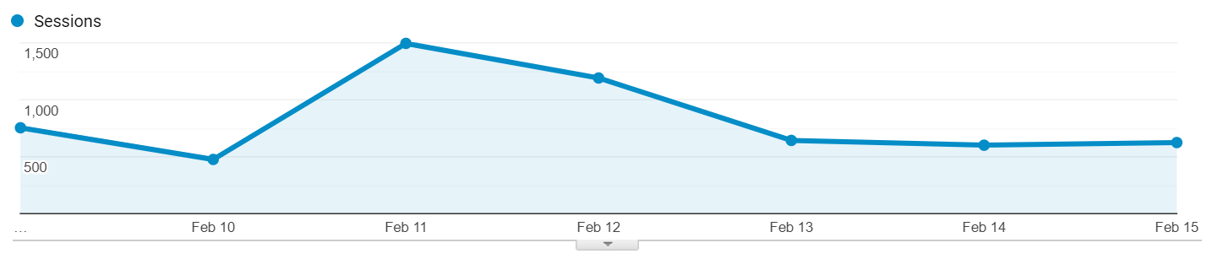
Unfortunately, some decrease in numbers this week because the influx from people coming in from the Ryerson story has dwindled down. Neglecting that, we’re actually doing quite well this week! We’re actually quite close to last week’s numbers if we don’t count the Ryerson story.

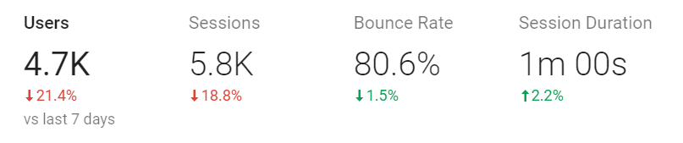
Bounce rate and session duration is still approximately the same as last week!

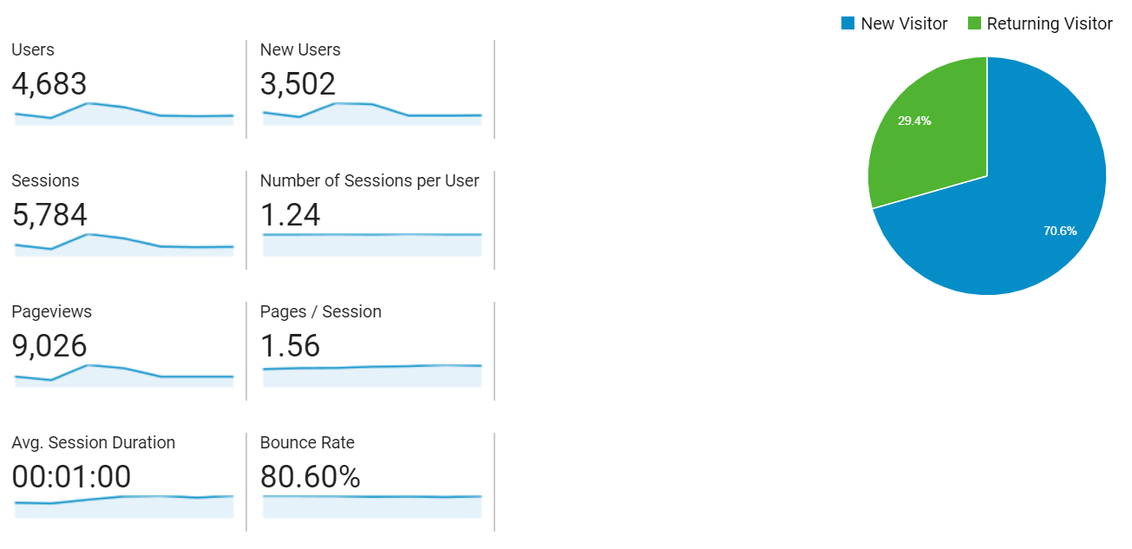

Acquisition
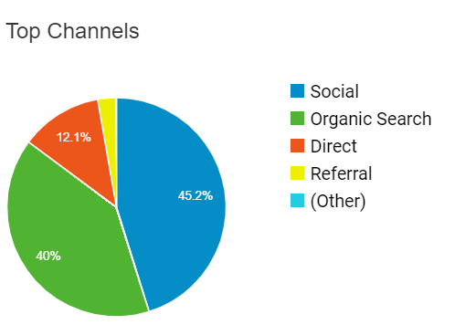
Social search is back to beating organic this week (last week was all just from the Ryerson national news)! Again, overall, we’re still going pretty strong.

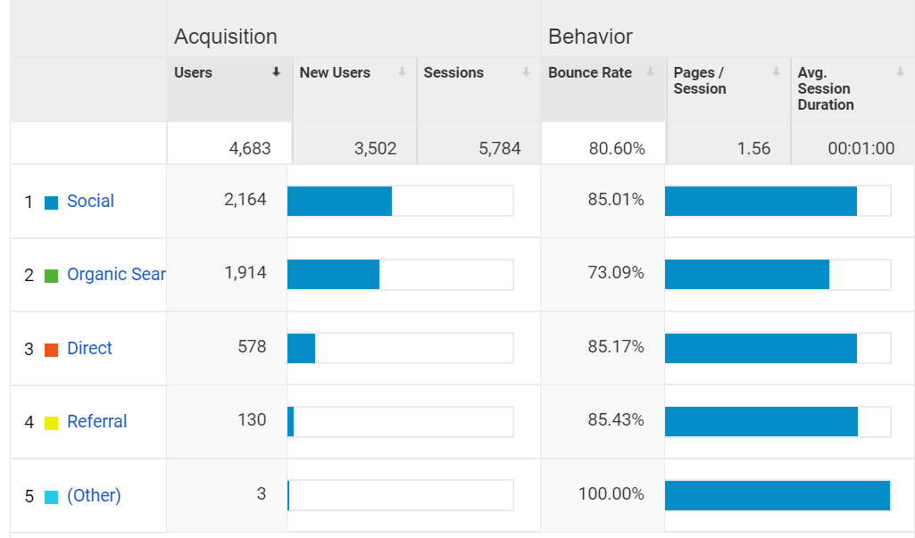

Twitter is actually improving a lot! The ratio compared to Facebook is significantly better than last week. We’re also getting some stuff from reddit and instagram stories (for some reason).
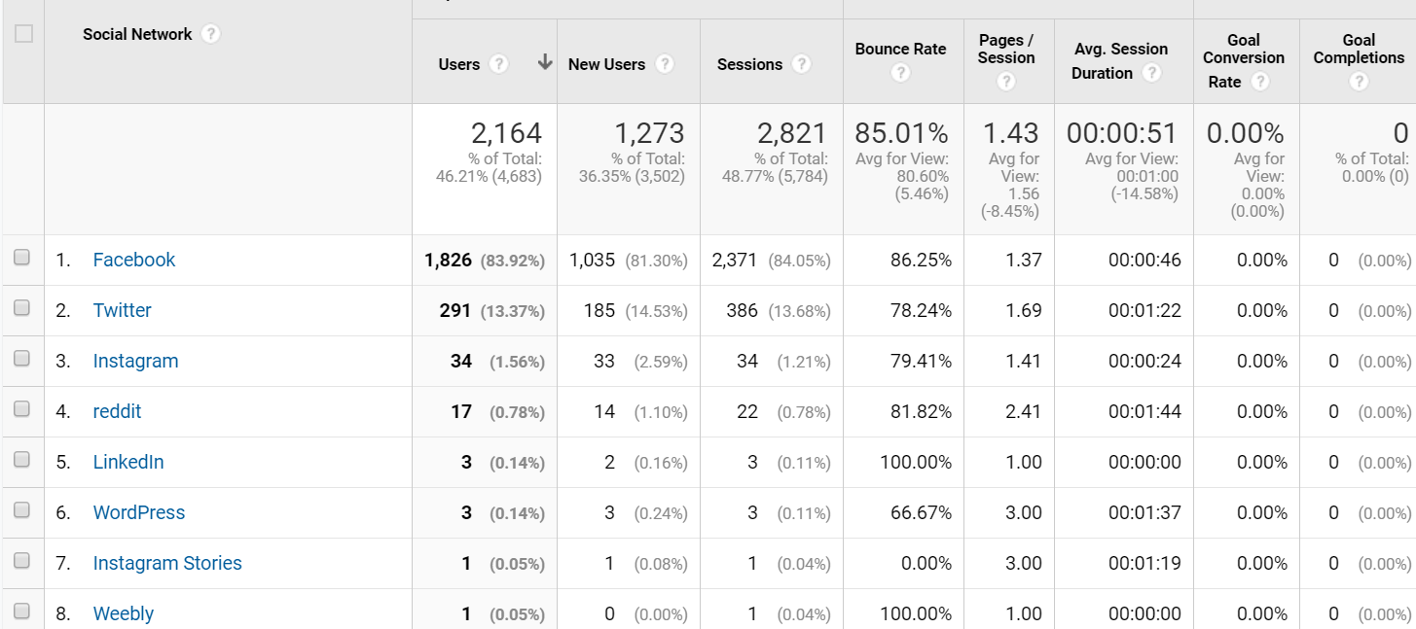

Behaviour
Top stories this week: Vanessa’s fake account, student union debate, UOSU winning, Ryerson national, and sugar dating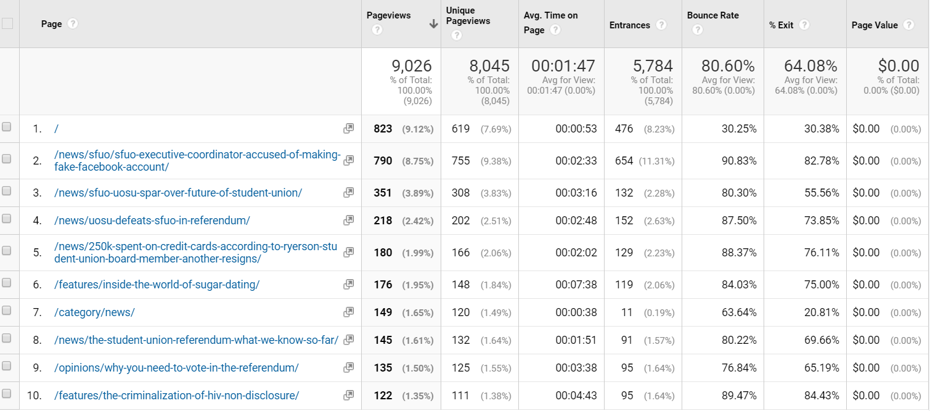
FACEBOOK INSIGHTS
Post Reach/Net Likes
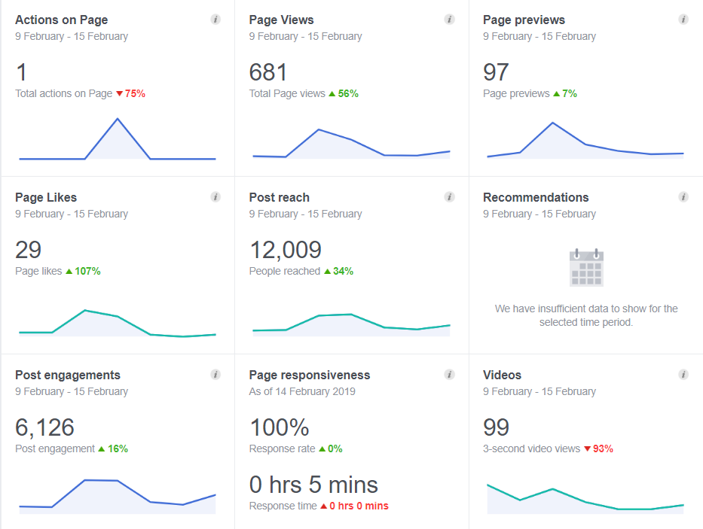
Facebook is still doing better and better. Our likes have gone up about 2x as much as last week and our reach has gotten to 12K this week!
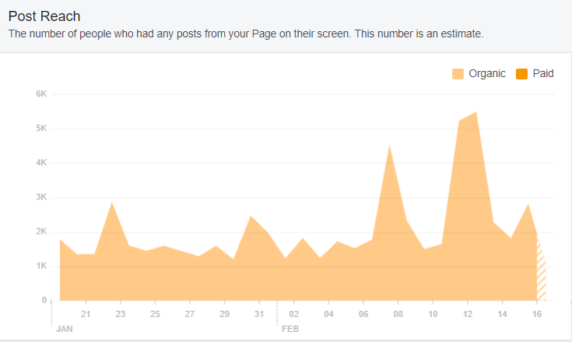

Top posts
Top posts this week: Favourite SFUO memories, Fyre festival tomato, snow day, referendum results, Vanessa’s fake facebook accounts

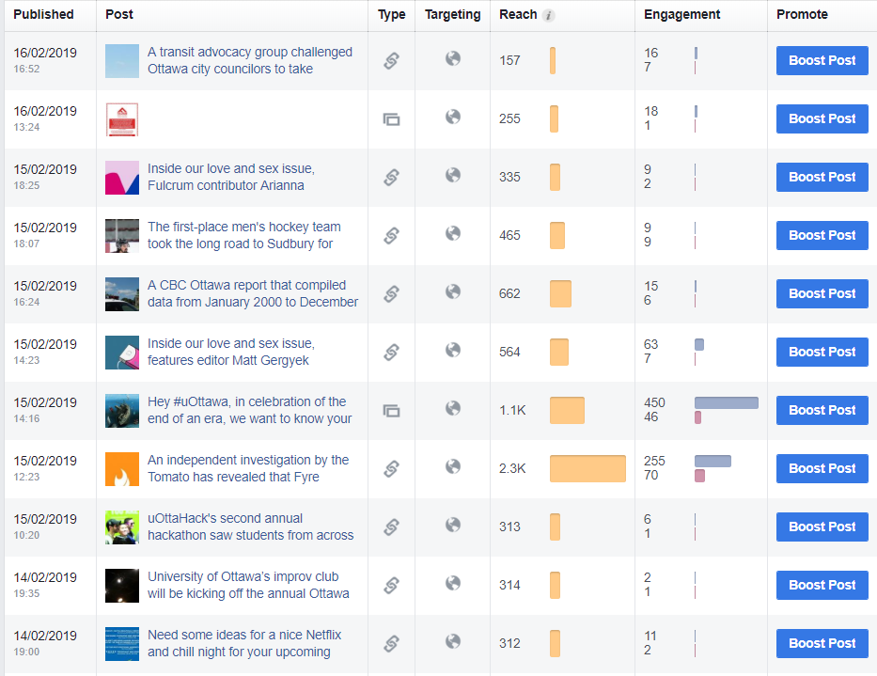
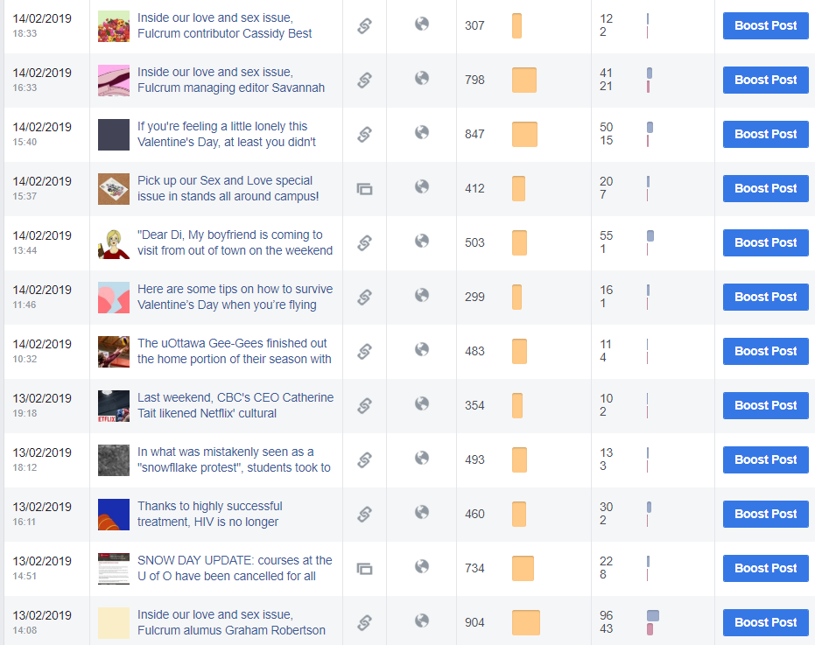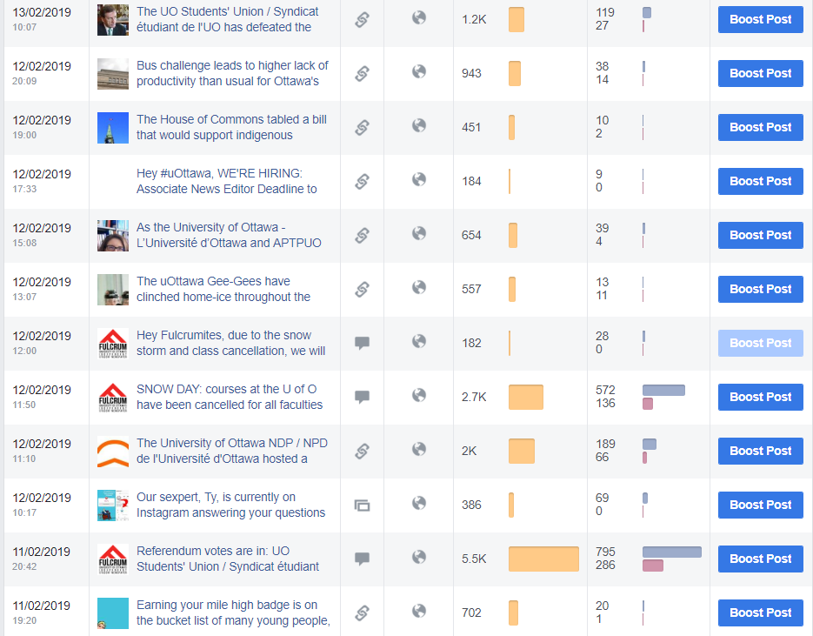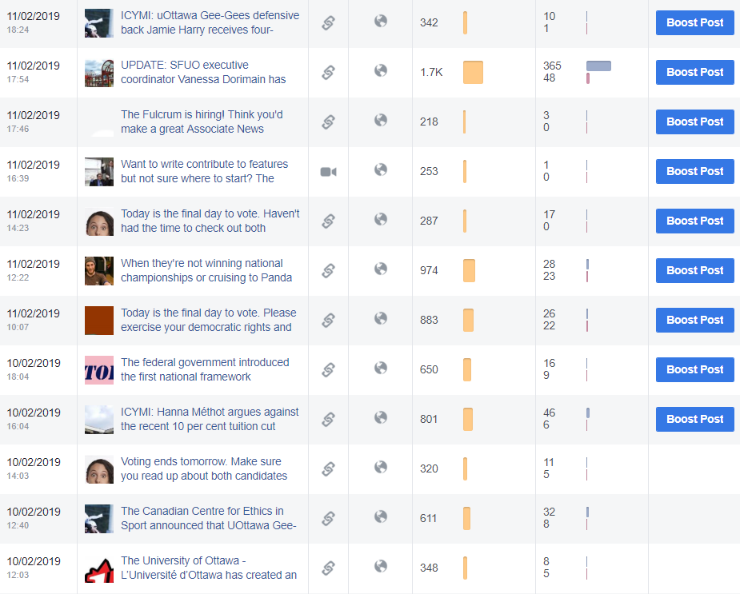

How we compare
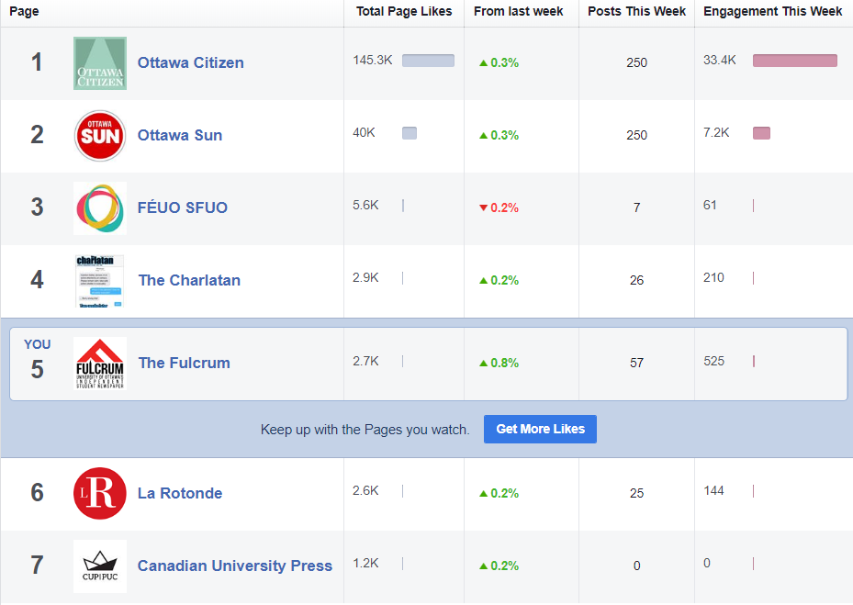
We’re doing really well in terms of increase in likes, let’s do our best to keep that going!

TWITTER ANALYTICS
Overview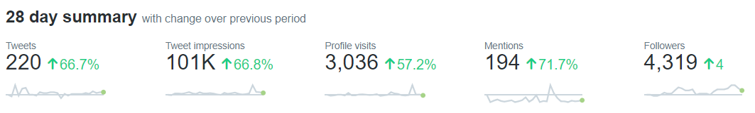

Twitter is also starting to pick up, our impressions doubled this week compared to our average, mostly from the referendum results tweet.

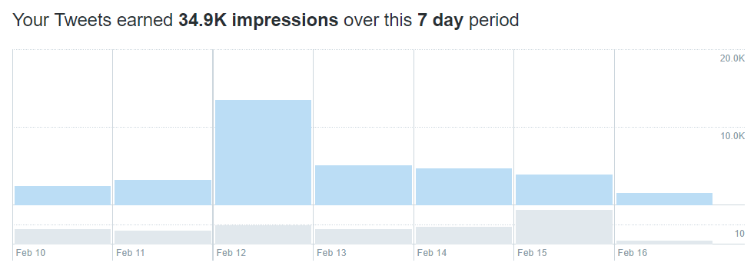

Link clicks, likes and retweets have gone up by a lot since last week, peaking on the day that we posted the referendum results, unsurprisingly.
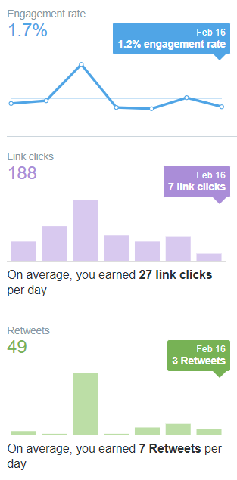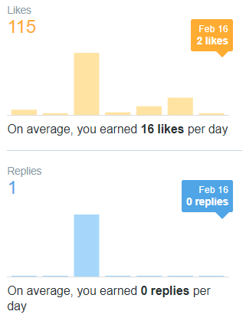

Top Tweets
Top tweets this week: referendum votes, hiring posts, snow day, Geegees charity, Vanessa story
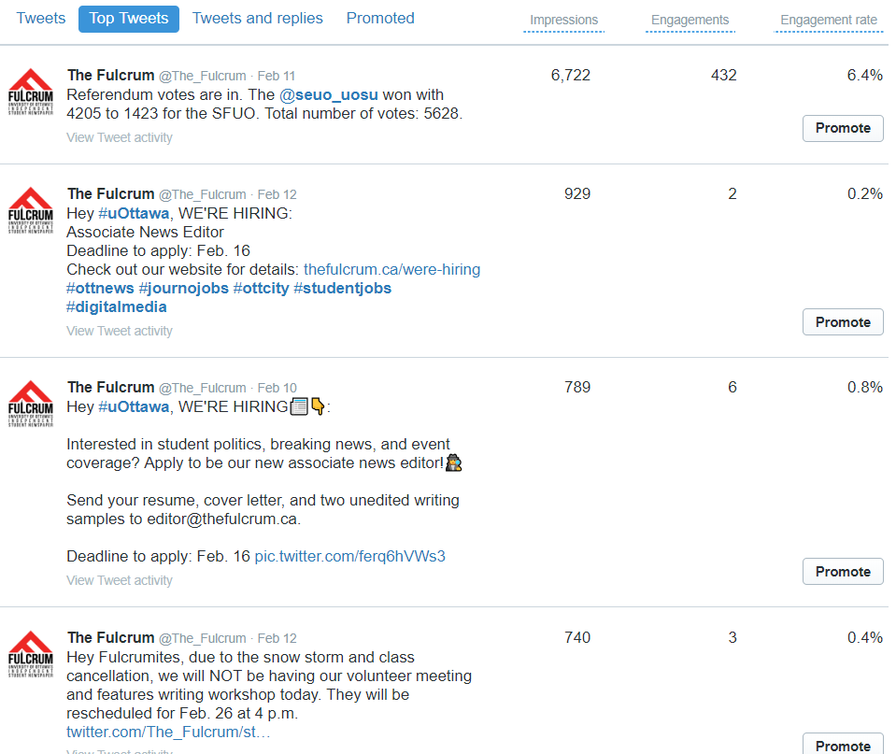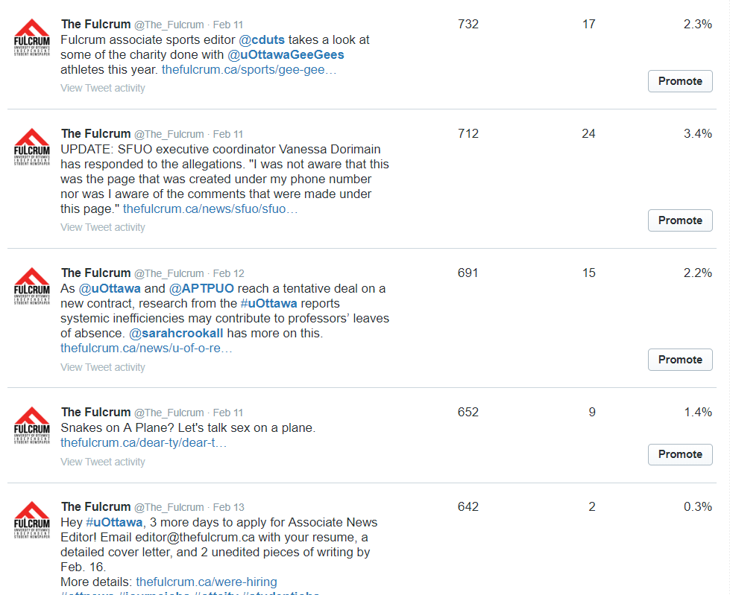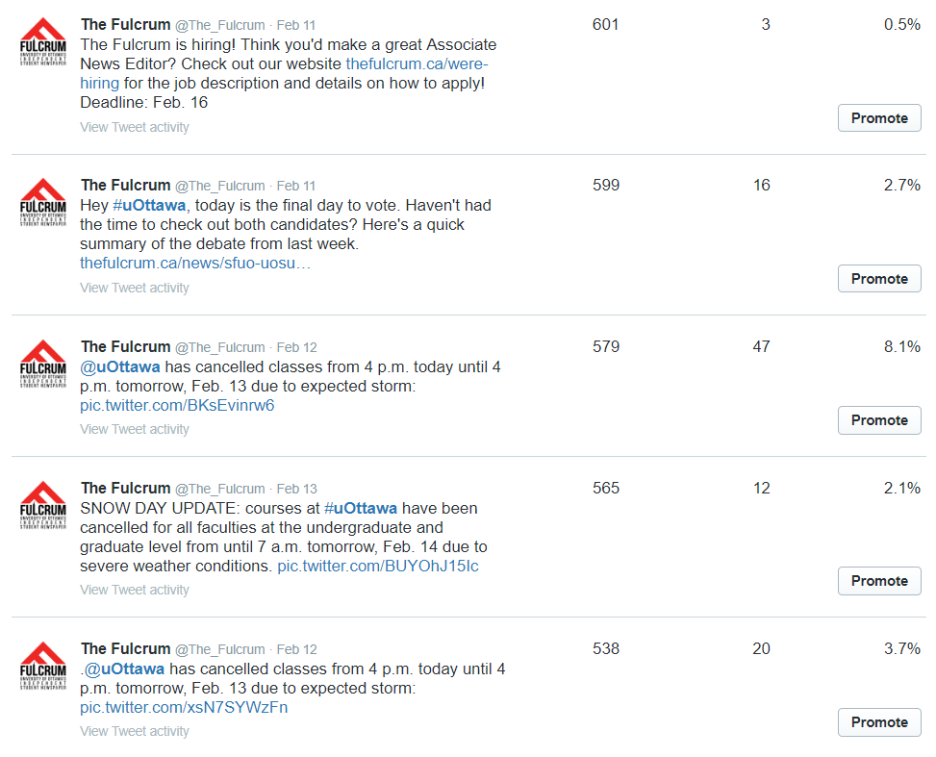
INSTAGRAM INSIGHTS
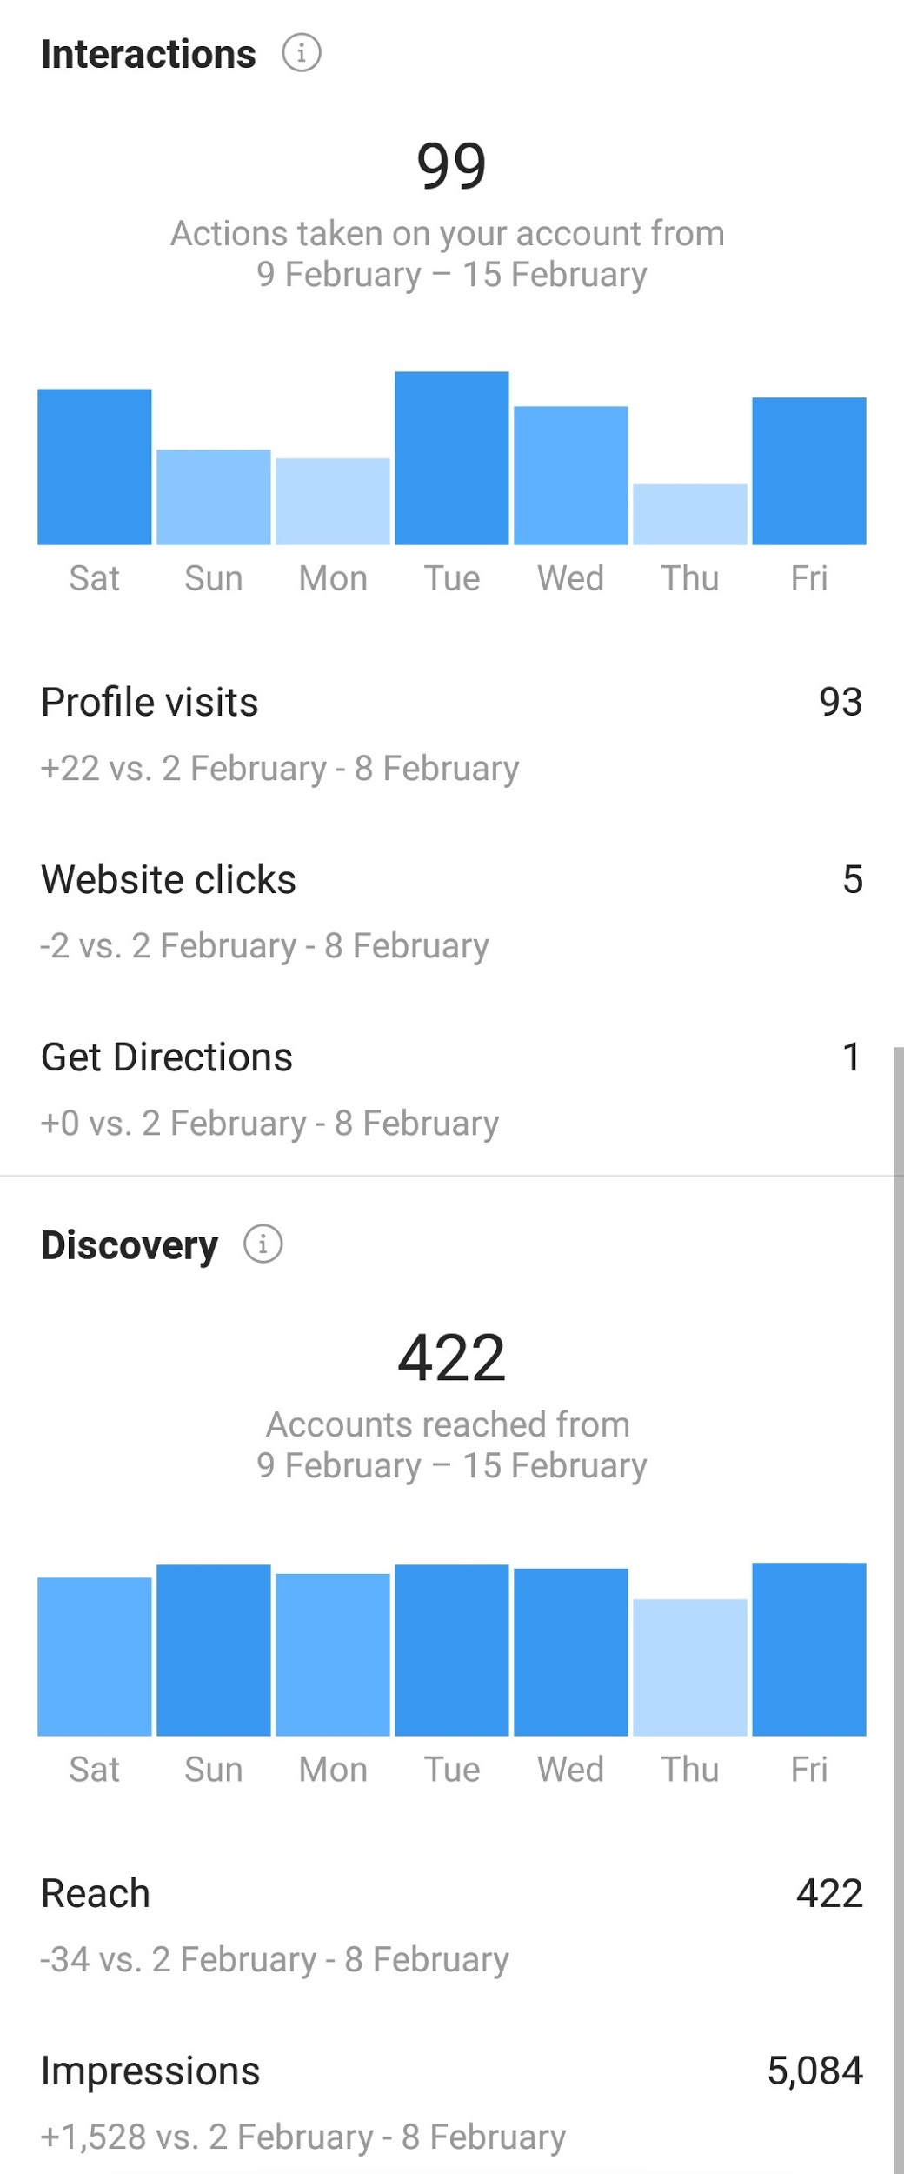

We’ve had a pretty big increase in interactions on instagram which is great. We’re also getting a good amount of followers and our stories have been doing better as well.

Fulcrum Analytics Report February 17 to February 23

FULCRUM WEBSITE ANALYTICS
Audience Overview
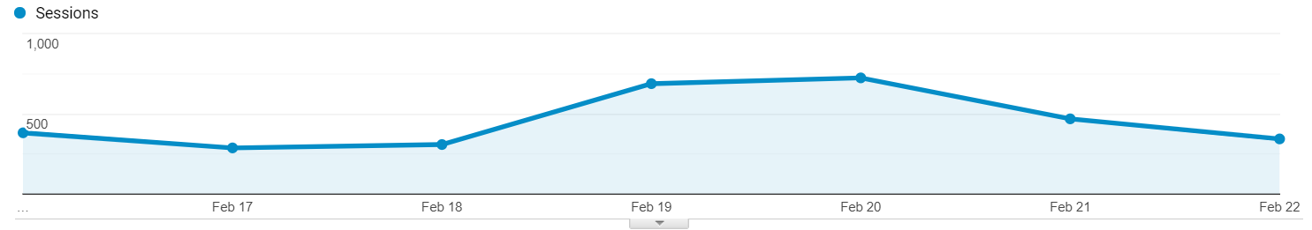
Drop in numbers this week in continuation from the drop last week with the Ryerson story. Overall average week, no breaking news. 2.7K users and 3.2K sessions is about average for our site.

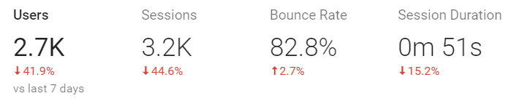

Pretty high ratio of new visitors vs returning this week.
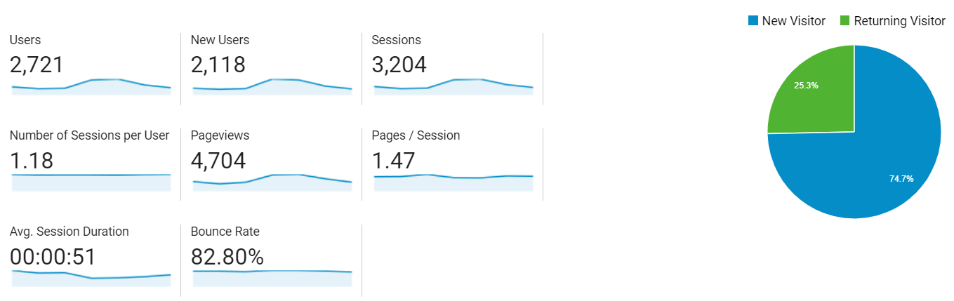

Acquisition
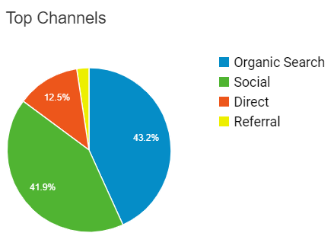
Unfortunately, organic search beat social this week but only by 35 stories. Overall, not a huge difference.

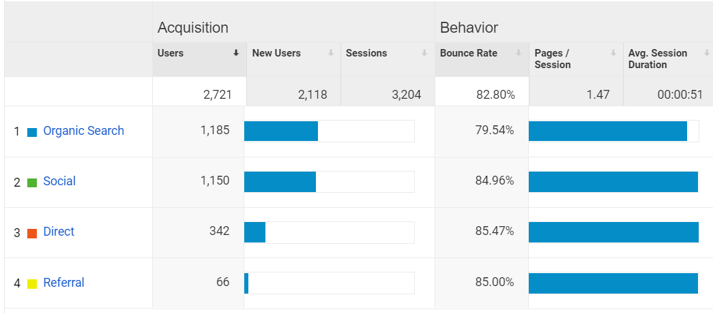

We got a bunch of acquisition from other sources like reddit, linkedin, etc. Blogger and Weebly have 100% bounce rate but the other ones were legitimate interest form other platforms.
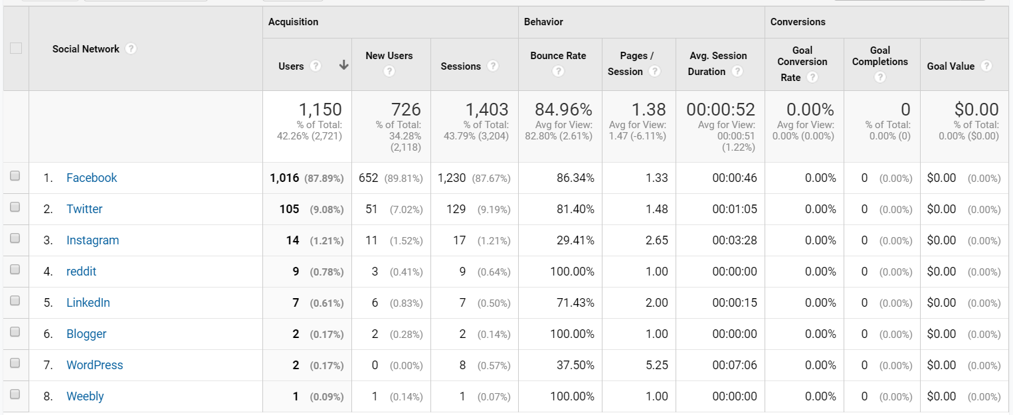

Behaviour
Top stories this week: UOSU transition, Pinoys on parliament, albums Radiohead album review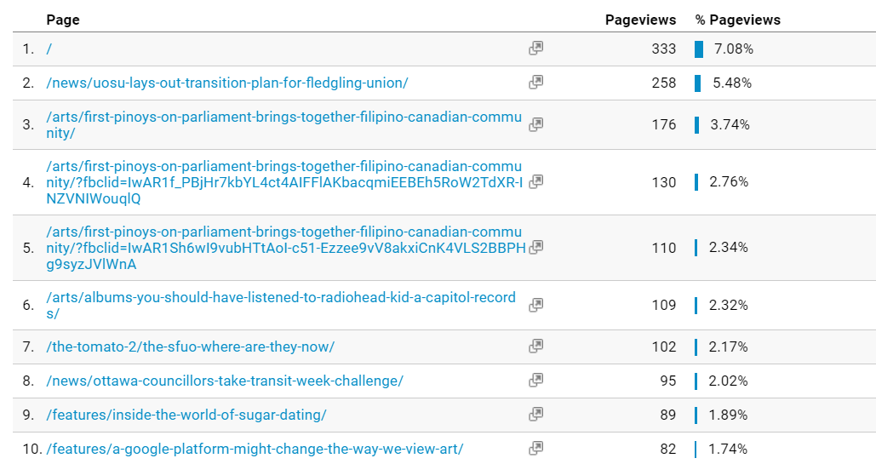
FACEBOOK INSIGHTS
Post Reach/Net Likes
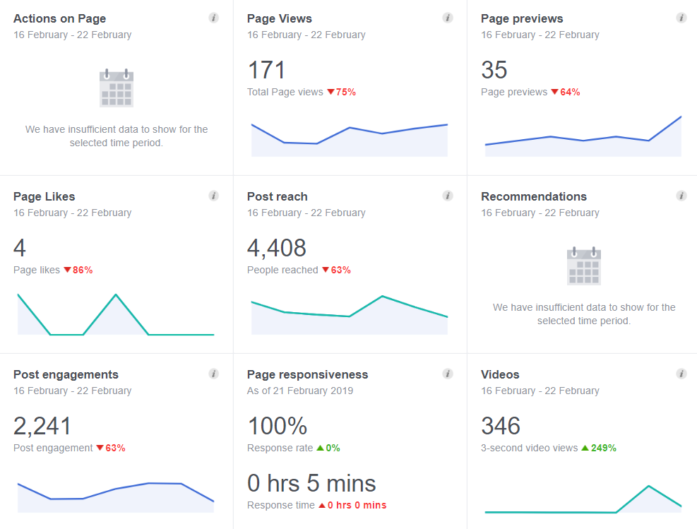
Unfortunately our like ratio has dropped a bit this week (only 4 new likes) and our post reach is still decreasing since we had a solid week last week.
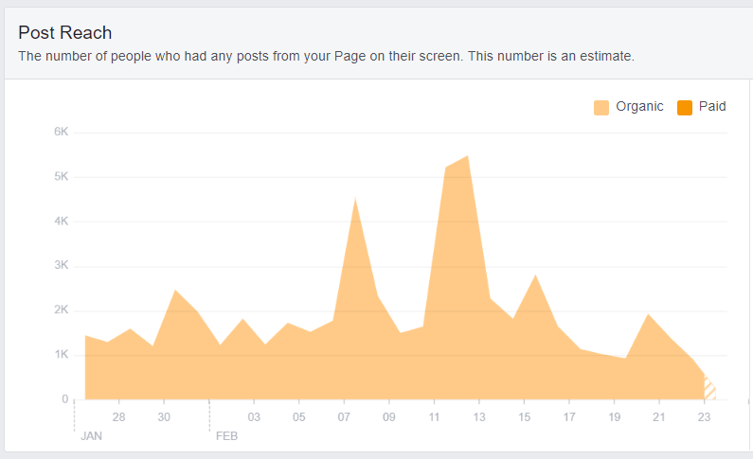

Top posts
Top posts this week: uottawant clinic, boardashians, sit down with UOSU

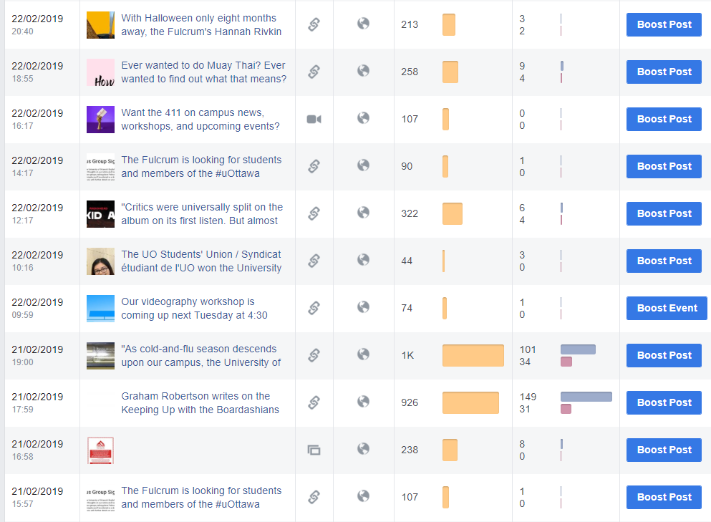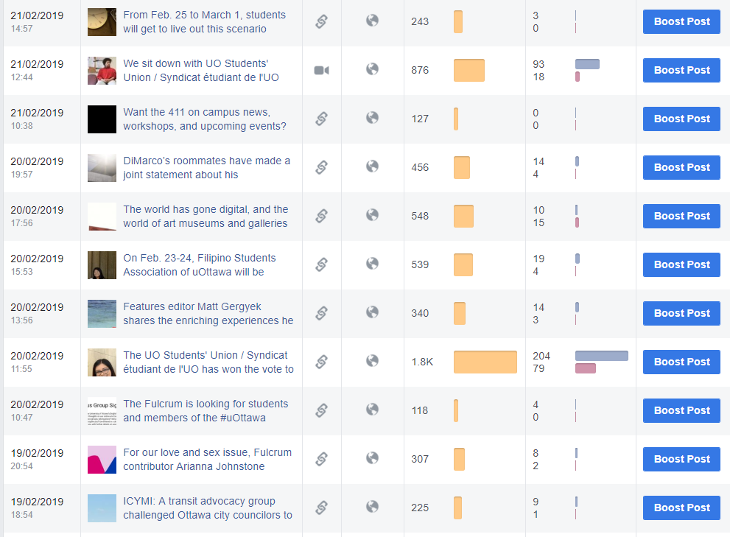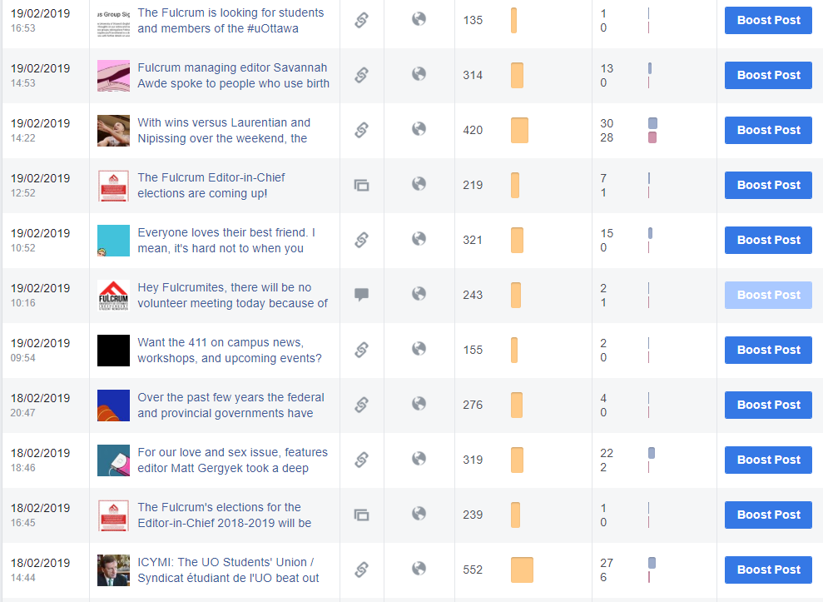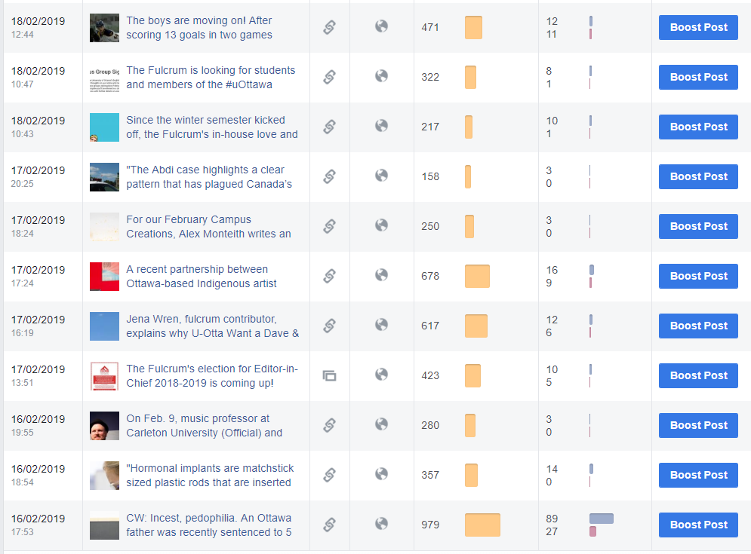

How we compare
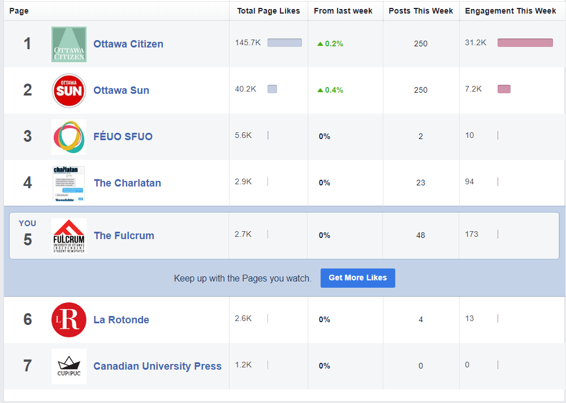
No increase in growth this week but we are doing pretty solid!

TWITTER ANALYTICS
Overview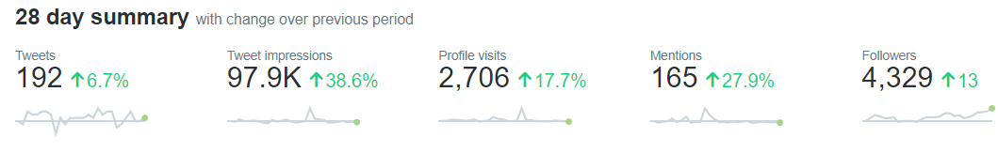

Twitter is still improving. We’ve had an increase of followers and impressions this week. Although our impressions went down, we did still have more impressions than our 10-15K average.

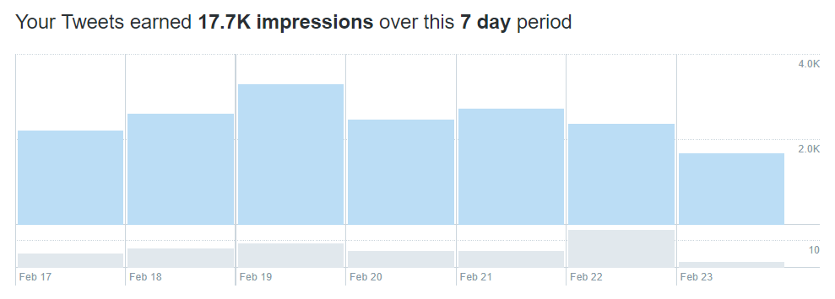

Engagement is still above average, link clicks did decently well this week, and likes were about average.
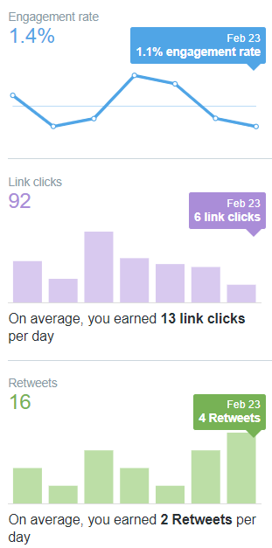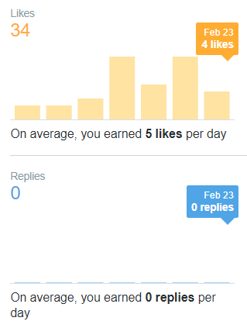

Top Tweets
Top tweets this week: Radiohead album review, anti-black racism, SEUO sit down
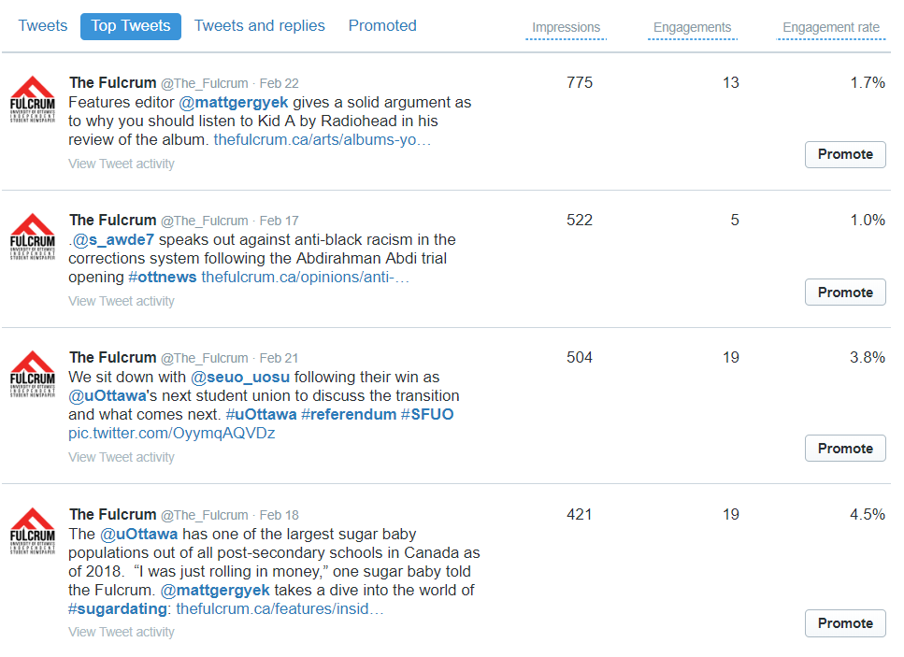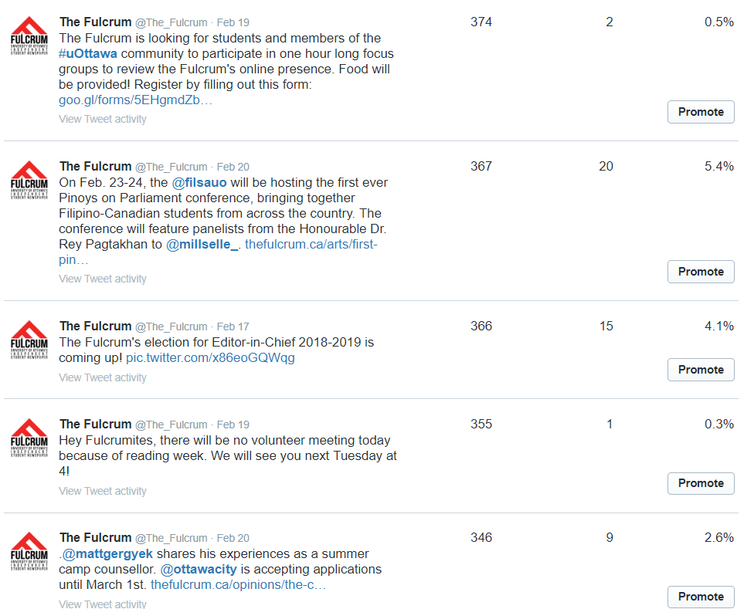
INSTAGRAM INSIGHTS
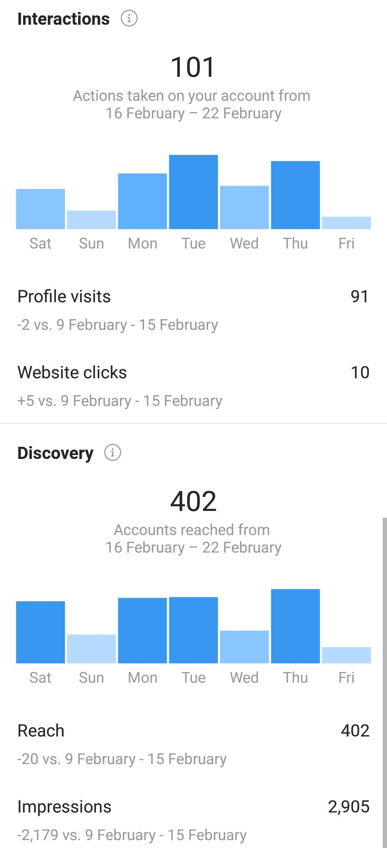

Interactions went up but discovery went down (both only by a bit). Instagram was about average this week with no big changes.

Fulcrum Publishing Society
Board of Directors
President’s Report
Sunday, February 24, 2019
141 Louis Pasteur, 10:30 a.m.
Meeting #9 2018-2019 Publishing Year

- Legal
Student Union Referendum
- Kate, Jon, Justin, Dorian, and I were in attendance for a meeting with the SFUO on January 29th, prior to the referendum. The meeting was straightforward. The SFUO executive discussed when we should be receiving our levies and imparted any details they have regarding the government’s student choice inititative. The minutes of this meeting have been saved in the drive.
- The student union referendum was held from February 8-11th. The SFUO lost the referendum to the new student union, the UOSU. The new union must hold elections in the coming months to determine their executive team. We will unfortunately not be able to contact anyone until then.
- We were under the assumption that student fees would be passed over to the new student union, however a recent statement from the uOttawa administration congratulating the new student union stated the following: “It is up to the newly-elected student association to determine which services should be offered. For each service, it will be responsible for securing the agreement of undergraduate students. That process will have to take into account the framework for student fees announced by the Ontario government earlier this year.” As such, we are a little unclear as to the state of our levy as of next year even without the added confusion of the Ontario government’s initiative.
- If we do manage to successfully lobby the government to deem the newspaper an essential service, our tactic will likely be to talk the university into distributing our levy without the additional step of the student union since we are an independent non-profit organization and could do without being associated with the student union. If not, we will have to speak with the new student union to renegotiate our levyand possibly hold a referendum?
Meeting with Fulcrum Lawyer RE: Provincial Government Cuts
- Dorian and I met with Jenna, the Fulcrum’s pro-bono lawyer at Norton-Rose Fulbright to discuss the current situation with The Ford Government as well as the Student Union referendum.
- The meeting was short. Dorian and I debriefed Jenna about the current situation, primarily focusing on the government’s student choice initiative. After listening to the situation, she advised that legal action against the government would be almost unprecedented, and would not be advisable. She agreed that a lobby effort is in our best interests and although it is not a guaranteed success, she believes it to be our best option. She is very familiar with Earnscliffe, the lobby firm selected to represent us, as her office has worked with them on other cases, and knows them to be a solid choice.
- In terms of potential legal action against the university- she would not be able to help us there because her firm/she represents the university, and that would constitute a conflict of interest.
ORCUP Lobby Campaign
- I had a meeting with the other Ontario papers to discuss the Lobby campaign. I spoke with representatives from La Rotonde and The Charlatan to have them join the meeting as well since they are not members of CUP.
- The meeting discussed the contract with the new firm, Earnscliffe, our current strategy, and how much each paper can contribute. There are four documents in the drive (president’s folder in February 2019 meeting) regarding this meeting and its’ specific details.
- The lobby firm will cost $23,000 over 3 months. The Fulcrum pledged to contribute $4500 over three months.
- Another important note from the meeting was that given The Varsity’s reporting on The Student Choice initiative, it is not our best move to directly lobby the University. In any case, the University is likely being bombarded with requests at the moment given the Student Union situation and now the provinces’ cuts and they are likely responding to no one. (https://thevarsity.ca/2019/02/05/potential-guidelines-for-student-choice-initiative-revealed/)
- I am still waiting for word on if we have received all of the funding necessary to hire the firm, however that news should come soon. I will update everyone accordingly.
- If for whatever reason the Lobby effort does not pull through, the BOD and EdBoard will need to come up with an organized campaign to advocate for the paper including class visits, social media efforts and editorials, among other ideas.
- Finance
SFUO Levy Update
- I believe we have received our fall levy, and our winter levy will come soon enough. The SFUO executive mentioned they will talk to the University about the levy coming so late.
- Finance needs to draft a ghost budget for next year without a levy as soon as possible as well as the regular budget including our regular levy. A draft should be completed by February’s Board meeting

Budgeting Note (repeated)
- Given the uncertainty of our financial situation this Winter, any non-discretionary spending must be put on hold for the moment if it hasn’t already been budgeted for. This includes parties, acting pay, etc. Until we are certain we will be receiving our money in the winter, we need to be conservative with our spending. If you are uncertain about what counts as non-discretionary, run it by me or Jon first!

- HR
Employee Roundtables
- I did not meet with the full-time staff this month, however monthly bilats will be scheduled at the February board meeting.
New employees
- Ryan Pepper is acting as the Arts and Culture Editor through the emergency hiring procedure. As is customary, Anchal has begun to advertise for his replacement online for a minimum of two weeks. In the event that not many or no applications are received for the position and Ryan is willing, we will need to re-approve him from Acting Editor to Editor.

- Training
- The strategic planning committee will be meeting to discuss our goals for the training session this semester. The theme will be the future of the Fulcrum given the union, the student choice intitiative and our transition to online.
- EdBoard is running trainings for volunteers and any interested parties during volunteer meetings on Tuesdays! You should attend if you are interested.

- Marketing and Branding Committee
- The committee met with Cassandra, our marketing consultant, on January 29th
- Kaylum will be providing us will a full marketing report at our February Board Meeting.
- Graham put together an infographic to promote our new website features. This should be advertised accordingly on social- has this been done?
- The readership survey continues to be advertised. Those results should come out soon.

- University Partnerships
- Given that we are transitioning completely away from print, it is important that we make an effort to be more visible on campus by collaborating with campus institutions.
- Omar from CHUO was very interested in a partnership with the Fulcrum’s EdBoard. His team, Anchal and the arts and culture rep will be working together on some interesting initiatives.
- In terms of a panel discussion with IvoteJeVote and IFSD, we wil need to have more discussion about that. I spoke again with Helaina Gaspard from the Institute of Fiscal Studies and Democracy at the University of Ottawa (IFSD) about hosting a panel discussion and the concept I think needs to be a bit more fleshed out. If this panel is something we really would like to do it will take quite a bit of work on our end and we need to consider if we would be willing to take on this workload at the moment.

- Inter-Board Relations Committee
- Justin has continued to meet with Ed Board each month.
- This month there is an Oscar night planned at the Royal Oak. (The evening of this board meeting)
- Policy
- The policy manuals are finally updated and are posted on the website! Thank you, Kate for all your hard work on this.
- Changes to job descriptions are now the priority before the end of the year

- Board Recruitment
- We have one new potential board members joining us for our meeting today for the student representative position.

654 07-85 University Private
Ottawa, ON
K1N 6N5
613-695-0060

Fulcrum Publishing Society – Board of Directors
Branding and Promotion Committee Report (Sunday, March 3rd, 2019)
Prepared by: Graham Robertson
Marketing Consultant
- Kaylum, Christine, and Graham had a meeting with our marketing consultant, Casandra, at the end of January, covering topics such as developing a target market, defining roles and responsibilities between Christine and Kaylum’s positions, and strategies for growing our social media following.
- Some of the content from the discussion was helpful, however there were a few areas of concern. Christine pointed out that some of the advice conflicted with the critique she received from Elamin from Buzzfeed during NASH, and other advice didn’t seem relevant to us as a news organization.
- A follow up email was sent to Casandra about these concerns, and we asked her to focus more on social media growth specifically for a news organization.
- At our meeting on February 28th, Casandra provided a presentation on strategies taken by other campus news outlets to grow their social media following, including giveaway campaigns and maintaining a 70% following/follower ratio. She also noted that we should continue doing market research ourselves.
- We should be doing a SWOT analysis for our business.
- Casandra will provide us with a list of helpful social media gurus to study.

Focus Groups
- We had intended to host focus groups during the month of February in order to evaluate our online presence and seek out opportunities for growth and improvement. The sign-up form had been circulated for a number of weeks on our social media, but the number of interested participants was much lower than anticipated. This could be due to a number of factors, such as unclear information in our social media posts, the ineffectiveness of using social media to promote this, the timing (e.g., midterms), or a general lack of interest. The marketing committee will discuss this at our next meeting to determine how we can incentivize people to participate.

General Notes
- Kaylum has provided the marketing committee with an updated marketing plan for the remainder of the year, including proposed events, budget, and targets for social media growth. Graham has provided some feedback, and is also hoping to have an updated budget at each committee meeting.
- Kaylum is looking to host a trivia night at FnS on March 9, with social media to begin shortly.
- Kaylum had discussed a guest speaker event with Anchal, with more details to follow (this should be finalized soon as the end of the publishing year is rapidly approaching!)
- There continues to be a degree of uncertainty in the division of roles and responsibilities between Christine and Kaylum’s positions. The marketing committee will be dedicating one meeting towards addressing this specifically, and determining what we’ll need to do with both positions as of May 1st. Any feedback on this is appreciated.

Fulcrum Marketing Plan

Target Market
Our Target Market has been identified as both male and females between the ages of 18-30
Our Target market are students enrolled at the University of Ottawa as either part-time or full-time students. These students should be active on at least 1 social media account and access to the internet and own a mobile device or laptop (Twitter, Instagram, and Facebook).

More specifically our target market primarily speaks English and is a current reader of the Fulcrum and regularly attends events at the University of Ottawa

What the Fulcrum provides
The Fulcrum provides timely and relevant news stories related to students.
The Fulcrum also provides Job opportunities and volunteer opportunities for students who are looking to gain experience in the journalism industry.

Market Research
We will conduct a survey to collect data on the Fulcrum in the eyes of our target market.
The information will help determine our SWOT (Strengths, weaknesses, opportunities and threats)
Focus Group – Dorian & Kaylum will conduct the Focus groups during the days.
Graham and Christine will conduct the Focus groups during the evening.
Facebook event page to be created.
Scheduled for After Reading week - Date is TBD

Objective – To gather more qualitative information in regards to our currents postings and our physical presence around campus

Goals
Sales Goals
Currently our main source of revenue come from our print issues. Since we will be removing print all together our only source of revenue will be from our online saes.
Print issue sales Objective- To sell $16,000 of print issue ads bye April 3rd 2019.
Online Sales goal – To sell an additional $1200 by April 3rd 2019.
Online Sales goal by Month

Month | Goal ($)
February | $300`
March | $400
April | $500

Social Media Goals
With the Fulcrum currently transitioning from print media to online our main focus is to grow our awareness of the Fulcrum and its presence on social media. We want to be recognized as the number one student media outlet here at the University of Ottawa. – Clear but now get more specific.
Currently we are on 4 social media platforms
For the duration of the second semester the Fulcrum will look to increase both our number of volunteers and its audience on social media through the means of various marketing strategies.
Current | Goal by April 2019
Instagram 604 Followers | Instagram 10% ( 60 followers)
Twitter 4323 Followers | Twitter 3% (130 Followers)
Facebook 2559 Followers | Facebook 5% (128)
YouTube 166 subscribers | YouTube 15% (25)
Volunteers | (Ed board goal)

For the duration of the second semester the Fulcrum will look to increase both our number of volunteers and its audience on social media through the means of various marketing strategies.

Social Media Strategies.
All other strategies aside from Social media contests will be implemented by Social Media Coordinator.

Social Media Contests
Social Media contest will be run to help reach our goals to increase our followers on our social accounts.
The Fulcrum will aim to run 2 social media contest a month. Alternating between Instagram and twitter.
The Contests will be run bi-weekly dependent of the month and the events taking place.
Social media contests will be run in correlation with upcoming events (Example: Oscar Night, The social media contest will be movie themed and the prize will be a Cineplex gift card). Fulcrum SWOT Analysis as a digital platform

Strengths | Opportunities
- Redesigned website  - Quality of content  - Constant updated content  - Large target market | - New to digital only( Exploring stages)  - Increase online sales  - Partnerships  - Events
Weaknesses | Threats
- Entertainment side is absent  - New to digital only | - A lot of competitors in media industry  - Better pricing elsewhere  - Revoke the student Levi

Budget
Total Budget | Budget used
$3000

Expenses
Item | Cost
2x Cineplex Gift Cards | $50
Trivia Night Gift Card | $25
Marketing Consultant | $825
Promotional Materials(Pens) | $298

Social Media Contest (SMC) and Events
January 1st- 31st
Sunday | Monday | Tuesday | Wednesday | Thursday | Friday | Saturday
 |  | 1. | 2. | 3. | 4. | 5.
6. | 7. | 8. | 9. | 10. | 11. | 12.
13. | 14. | 15.  Tabling UCU  Volunteer Recruitment | 16. | 17.  Tabling UCU  Volunteer Recruitment/In  Class talks | 18. | 19.
20. | 21.  SMC  Instagram | 22.  SMC  Instagram | 23.  SMC  Instagram | 24.  SMC  Instagram | 25.  SMC  Instagram  Ends | 26.
27. | 28.  SMC  Capital Hoops | 29.  SMC  Capital Hoops | 30.  SMC  Capital Hoops | 31.  SMC  Capital Hoops  Ends

February 1st – 28th

Sunday | Monday | Tuesday | Wednesday | Thursday | Friday | Saturday
 |  |  | . |  | 1. CAPITAL HOOPS CLASSIC | 2.
3. | 4. | 5. | 6. | 7. | 8. | 9.
10 | 11. | 12. | 13.  SPECIAL ISSUE | 14. | 15. | 16.
17. | 18.  SMC  Cineplex  /Promote Oscar Night | 19.  SMC  Cineplex  /Promote Oscar night | 20.  SMC  Cineplex  /Promote Oscar night | 21.  SMC  Cineplex  /Promote Oscar night | 22.  SMC  Cineplex  Ends | 23.
24.  Oscar Night  Royal Oak | 25. | 26. | 27. | 28.

Guest Speaker TBD*
Focus Group – TBD*

March 1st – 31st
Sunday | Monday | Tuesday | Wednesday | Thursday | Friday | Saturday
 |  |  |  |  | 1.  Promote Trivia night | 2.  Promote Trivia night
3.  Promote Trivia night | 4.  Promote Trivia night | 5.  Promote Trivia night | 6.  SPECIAL ISSUE  House ad for Trivia night | 7.  Promote Trivia night | 8.  Promote Trivia night | 9.  Pub Night Trivia @FNS
10. | 11. | 12. | 13. | 14. | 15. | 16.
17. | 18.  SMC  Poutine Giveaway | 19.  SMC  Poutine Giveaway | 20.  SMC  Poutine Giveaway | 21.  SMC  Poutine Giveaway | 22.  SMC  Poutine Giveaway | 23.  SMC  Poutine Giveaway
24. | 25. Poutine Fest | 26. Poutine Fest | 27.Poutine Fest | 28.Poutine Fest | 29.Poutine Fest | 30.
31.

April 1st- 30th

Sunday | Monday | Tuesday | Wednesday | Thursday | Friday | Saturday
 | 1. | 2. | 3.  Special Issue | 4. | 5. | 6.
7. | 8. | 9. | 10. | 11. | 12. | 13.
14. | 15. | 16. | 17. | 18. | 19. | 20.
21. | 22. | 23. | 24. | 25. | 26. | 27.
28. | 29. | 30.

654 07-85 University Private
Ottawa, ON
K1N 6N5
613-695-0060

Fulcrum Publishing Society – Board of Directors
Inter-board Relations Committee Report (Sunday, March 3, 2019)
Justin Turcotte

- Health and Safety Stress Questionnaire

The Fulcrum’s Health and Safety Stress Questionnaire was distributed to all employees during the November Strategic Planning Session on November 25th, 2018. Ultimately, seven completed questionnaires were returned and two partially completed questionnaires, for a total of nine questionnaires. This represents 60% of our staff (9/15).

The questionnaire consisted of 24 multiple choice and short answer questions. The questions are numbered 1 to 22 and then 27 to 28, numbers 23 to 26 do not exist because of an oversight.

The questionnaire was adapted from a Canadian Union of Public Employees (CUPE) Health and Safety Branch document.

The questionnaire itself can be found in the folder where this document was found.

- Questionnaire Results

Below you will find a snapshot of some important results generated from the questionnaire. The full results are available in both an Excel and Google Sheets document in the folder for this month’s Board meeting, and the Inter-board Committee folder, titled “Results - Health and Safety Stress Questionnaire”.

Since starting your work at The Fulcrum has your workplace stress increased?
- Yes - 8/9 (88.9%)
- No - 1/9 (11.1%)
- Don’t know - 0/9 (0%)

In your opinion, has the quality of your work suffered because of workplace stress?
- Yes - 1/9 (11.1%)
- No - 2/9 (22.2%)
- Sometimes - 6/9 (66.6%)

In your opinion, has your job satisfaction declined because of your workplace stress?
- Yes - 3/9 (33.3%)
- No - 3/9 (33.3%)
- Sometimes - 2/9 (22.2%)

Most common changes to job description:
- More duties have been added - 4/4 individuals who said that their job description had changed (100%)
- More meetings - 3/4 (75%)

In the last while, has your level of control over your job:
- Increased - 3/9 (33.3%)
- Decreased - 1/9 (11.1%)
- Remained about the same - 4/9 (44.4%)
- Don’t know/can’t say - 1/9 (11.1%)

Main causes of stress at workplace:
- Inadequate pay - 5/9 (55.5%)
- Lack of control over your job - 3/9 (33.3%)
- Overwork/accelerated work pace - 3/9 (33.3%)
- Forced overtime/long hours - 3/9 (33.3%)
- Conflicting job demands - 3/9 (33.3%)

Is stress a health and safety hazard/problem in your workplace?
- Yes - 3/9 (33.3%)
- No - 3/9 (33.3%)
- Sometimes - 2/9 (22.2%)
- No response - 1/9 (11.1%)

Health effects because of workplace stress:
- Depression and anxiety - 6/9 (66.6%)
- Fatigue - 5/9 (55.5%)
- Trouble sleeping/insomnia - 4/9 (44.4%)
- Unable to relax - 4/9 (44.4%)
- Tense more often - 4/9 (44.4%)
- Increased use of alcohol and drugs - 1/9 (11.1%)

Suggestions for solving stress problems in your workplace (emphasis added):
“Email cut off times, more willingness to help outside of listed job duties” - Individual #2

“Increased communication (Slack), mental health/self-care activities, debriefing” - Individual #3

“Flexible workload, better pay” - Individual #5

“Communication, team support, higher rate of pay, mental health check-ins simultaneous with performance reviews” - Individual #7

“Communication on a human level - not just work stuff” - Individual #8

Other remarks:
“For an unending news cycle it may be beneficial to consider whether employees are taking enough breaks to ensure their health remains intact. I'm not sure what this would look like, but I think it could prevent mental burnout so prevalent in this line of work.” - Individual #7

“Scent-free policy please” - Individual #9

- Moving Forward

It is up to the Board to determine what to do with these results. I recommend sharing the findings of the questionnaire with all business and editorial employees, as well as any action the Board decides to pursue.

In the future, this questionnaire could be improved by moving it onto an online platform. This would hopefully result in a higher response rate (some editorial staff never come into the office) and would make for easier and more detailed analysis of the results. A good option might be Survey Monkey, which all uOttawa users can now access for free.

Any questions about the questionnaire can be directed to Justin Turcotte at jturc022@uOttawa.ca.

- Editorial Board

I met with the Editorial team on Monday, 28 January to update them on the business we had discussed at our Board meeting the day before. I also shared the favourite pieces from the Board. At my next meeting, I am going to mention that EdBoard should not take the Board’s favourite articles as approval or disapproval for what they are writing.

One of the editorial team members asked what it meant that The Fulcrum would not be taking a position on the student union referendum. I clarified myself by stating that the Board and The Fulcrum Publishing Society would not be taking a position on the referendum. Editors were free to write based on their own policies.

One of the editorial team members asked if the Board would be meeting with a UOSU representative before the election. This did not happen to my knowledge.

At my next meeting with the editorial team, I will mention that there is an empty ex-officio spot on the Board which is reserved for an editor elected by the contributors if anyone is interested.

- Events

The Fulcrum’s Annual Oscar Party happened last Sunday, 24 February. 11 people attended, including two volunteers. We had $300 in contra at the Royal Oak on Laurier, of which we used most, but not all. Kaylum won the $25 gift card to Cineplex for correctly predicting 15 of the 24 Oscar awards. Five people tied for second place getting 11/24.

Fulcrum Pub Trivia Night is tentatively scheduled for March 9th I believe. Follow-up may be required on this one.

654 07-85 University Private
Ottawa, ON
K1N 6N5
613-695-0060

Fulcrum Publishing Society – Board of Directors
Policy Committee Report (Sunday, Februay 24, 2019)
February Policy Meeting: Wednesday, February 27, 2019
Present: Kate Murray, Denray Jean-Jacques, Donya Ashnaei, Graham Robertson, and Anchal Sharma
Updates
Following a review of the proposed amendments to the bylaws that were presented at the January Board meeting as well as some further suggested amendments from Justin, they were voted to be approved via email vote. These approved amendments have been added to an ongoing document to be further approved at the upcoming AGM.

February Meeting
The focus of this month’s meeting was to review and update updating the job descriptions at the end of the policy manual, which can be seen below. Most of the changes relate to making points relevant to the transition online as well as removing descriptions of positions that no longer exist and adding descriptions for newly created positions.

The following are the changes that the committee proposes:

Appendix A: Executive officers

President
- Reviews policy drafts in consultation with the Board

Appendix B: Business Department Employees

General Manager

General
- Coordinates production of bound editions

Board Note-taker → completely remove section

On-Campus Distributor → completely remove section

Appendix C: Editorial Employees

Editor-in-Chief
- Determines number of issues published and sets circulation in consultation with the Production Manager
- Selects a printer for the publishing year in consultation with the Production Manager
- Determines, in conjunction with the Managing Editor Production Manager, the Fulcrum’s copy chain, including but not limited to choosing which staff positions (located in Appendix C) will be hired and what format pages will be edited in
- Works with the Social Media Manager Managing Editor to develop and implement a social media strategy for promoting the Fulcrum online
- Oversees and coordinates the mediation committee in consultation with the General Manager Production Manager
- Maintains the advertising ratios in cooperation with the Production Manager
- Maintains relations between the Fulcrum and outside organizations → Move to Social Media Manager section
- Develops internal and external strategies to increase the visibility of the paper on campus → Move to Social Media Manager section
- Investigates marketing opportunities for the paper throughout their term → Move to Social Media Manager Section

Managing Editor
- Updates Facebook page and Twitter feed on a regular basis
- Works with the Associate Online Editor to Ensures secure consistency and high quality for all web content
- Assists with coverings breaking news events as they occur for online purposes. Responsible for proofreading pages on Tuesday evenings if a Staff Proofreader is not hired
- Regularly uploads new, web exclusive content (written, audio, and/or video
- Works with the Editor-in-Chief and Production General Manager to handle human resources and other in-house issues
- Seeks and oversees freelance contributors volunteer fact-checkers and proofreaders

Production Manager → completely remove section

Section Editors (News, Arts and Culture, Sports, Features, and Opinions)
- Liaises with the Production Manager and Visual Editor about the layout of her section
- Ensures there is sufficient copy to fill the space assigned by the Production Manager
- Uploads all print content to the Fulcrum website each week
- Is responsible for working with the Editor-in-Chief and the Social Media Manager Online Editor to develop an online strategy that integrates the editor’s section with the website, including but not limited to social media use, video content, liveblogging, podcasting, and alternative story forms
- Provides adequate training to the incoming section editor → this point is repeated twice

Online Editor → completely remove section

Associate Online Editor → completely remove section

Visual Editor
  - Is responsible for the coordination of the cover in conjunction with the Production Manager
  - Is responsible for managing and regularly updating the Fulcrum’s Flickr pool

Associate News Editor
  - Must write a minimum of two stories per week per issue as assigned by the News Editor

Multimedia Coordinator → completely remove this section and move some points to other sections
- Works closely with the Social Media Manager Managing Editor and Visual Editor to generate and promote multimedia content for the Fulcrum→ move to section editors section
- Work with the Managing Editor and Visual to solicit volunteers for multimedia content production
- Responsible for the multimedia content accompanying two story assignments per week (including but not limited to video, podcasting, slideshows, live-blogging and other interactive content, etc.) as assigned by the Managing Editor, or multimedia content accompanying one story assignment, and photo assignments accompanying three stories per week, as assigned by the Managing Editor, and Visual Editor → move to section editors section
- Responsible for creating one multimedia product every two weeks in consultation with the Managing Editor, in addition to weekly multimedia content
- Responsible for covering special events upon request of the Editor-in-Chief and/or the Managing Editor
- Ensure all multimedia content is of consistent quality and style → move to social media manager section
- Maintain and promote the Fulcrum YouTube channel → move to social media manager section
- Must educate all interested volunteers upon the request of the Editor-in-Chief and/or the Managing and Visual editors → move to the section editors section
- Attends Editorial Board meetings upon request
- Attends all staff meetings
- Responsible for maintaining all video, photography and digital equipment → move to visual editor section
- May only be excused from any of their duties by the Editor-in-Chief

Proofreader → completely remove this section

Videographer
- Responsible for creating one video per week
- Responsible for editing video content
- Works closely with Section Editors to come up with ideas for new content
- Seeks volunteers for their section
- Ensures production deadlines are met
- Helps with the general upkeep of the office
- Attends all staff and Editorial Board meetings
- Encourages volunteers to attend meetings
- Provides adequate training for the incoming Videographer
- Writes an end-of-term transition report
- May only be excused from their duties by the Editor-in-Chief

**A job description for the Social Media Manager will need to be added after the Strategic Planning Session**

